**TITLE OF THE PROJECT**

**By**

**Student Name**

**A PROJECT SUBMITTED TO**

**INTERNATIONAL COLLEGE OF BUSINESS AND TECHNOLOGY (ICBT)**

**IN PARTIAL FULFILLMENT OF THE REQUIREMENTS**

**FOR THE**

**Programme title**

**Month Year**

**International College of Business and Technology (ICBT)**

Statement of originality of submitted work

I,………………………………………………………………………..( Student Name)

Student ID Number ……………………………………………………………………….

Module number……………………………………………………………………………

Here by confirm that the work presented here in this report, and in all other associated material, is wholly my own work, and I agree to assessment for plagiarism

Signature……………………………………………

Date…………………………………………………

**Plant Cultivation and Monitoring Solution using IOT and Machine Learning**

By

Student Name

**ACKNOWLEDGEMENT**

**ABSTRACT**

**TABLE OF CONTENTS**

1. CHAPTER 1: INTRODUCTION 10

1.1. PROBLEM STATEMENT 11

1.2. Literature Review 12

1.3. PROJECT OBJECTIVE 14

1.4. RESEARCH QUESTION 15

1.5. RESEARCH OBJECIVES 16

1.6. PROJECT SCOPE 16

1.7. LIMITATION OF THE STUDY 17

1.8. SIGNIFICANT OF THE STUDY 18

1.9. DESIGN OVERVIEW 19

2. CHAPTER 2: LITERATURE REVIEW 20

2.1. DEPENDANT VARIABLE 20

2.2. INDEPENDENT VARIABLE 28

2.3. MODERATING VARIABLE 35

2.4. UNDERLYING THEORY 36

2.5. GAPS IN LITERATURE REVIEW 37

2.6. HYPOTHESIS DEVELOPMENT 39

3. CHAPTER 3: METHDOLOGY 40

3.1. THEORITICAL FRAMEWORK 40

3.2. POPULATION 41

3.3. RESEARCH APPROACH 43

3.4. MEASURES AND INSTRUMENTS 44

3.5. DATA COLLECTION 46

3.6. DATA ANALYSIS 48

4. CHAPTER 4: BACKGROUND OF THE STUDY 49

4.1. WHAT IS IT 49

4.2. WHY IT IS IMPORTANT 50

4.3. LIST OF ALL USER REQUIREMENTS 51

4.4. EXPLANATION OF THE CURRENT SYSTEM 51

4.5. DRAW BACKS OF THE CURRENT SYSTEM 52

4.6. EXPLANATION OF THE PROPOSED SYSTEM 53

5. CHAPTER 5: FEASIBILITY STUDY AND REQUIREMENTS GATHERING 54

5.1. FEASIBILITY STUDY 54

5.1.1. COST FEASIBILITY 54

5.1.2. TIME FEASIBILITY 54

5.1.3. SCOPE FEASIBILITY 55

5.1.4. TECHNICAL FEASIBILITY 55

5.2. REQUIREMENTS GATHERING 55

5.2.1. SELECTING THE SUITABLE FACT GATHERING TECHNIQUE 55

5.2.2. FACT GATHERING USING SELECTED TECHNIQUES 56

5.2.3. REQUIREMENTS DETERMINATION 57

5.2.4. RESOURCE IDENTIFICATION 58

5.3. THE SOFTWARE PROCESS MODEL 59

6. CHAPTER 6: DOMAIN INVESTIGATION 60

6.1. DECISION SUPPORT TOOLS (business decisions) 60

6.1.1. DECISION THEORY 60

6.1.2. DECISION TREE 60

6.2. TECHNICAL RESEARCH 61

7. CHAPTER 7: DESIGN 62

7.1. DESIGN OVERVIEW 62

7.2. DESIGN OF THE SYSTEM 62

7.3. INTRODUCTION TO DATABASE DESIGN 69

7.3.1. ENTITY RELATIONSHIP DIAGRAM (ERD) 69

8. CHAPTER 8: IMPLEMENTATION 70

8.1. IMPLEMENTATION OVERVIEW 70

8.2. USER INTERFACES 71

8.2.1. USER INPUT INTERFACE DESIGNS 71

8.2.2. USER OUTPUT INTERFACE DESIGNS 73

9. CHAPTER 9: TESTING 76

9.1. TESTING OVERVIEW 76

9.2. TEST STRATEGY -UNIT TESTING 76

9.2.1. TEST STRATEGY -INTEGRATION TESTING 76

9.2.2. TEST STRATEGY- FUNCTIONAL TESTING 76

9.2.3. TEST STRATEGY – REGRATION TESTING 77

9.3. TEST PLAN AND TEST CASES 77

10. CHAPTER 10: MAINTENANCE 84

10.1. OVERVIEW OF MAINTENANCE 84

11. CHAPTER 11: CRITICAL EVALUATION AND CONCLUSION 86

11.1. SUMMARY OF THE PROJECT 86

11.2. EVALUATION OF THE SOLUTION 87

11.3. LIMITATIONS OF THE SYSTEM 88

11.4. FUTURE ENHANCEMENTS 90

11.5. LESSONS LERANED REPORT 92

11.6. CONCLUSION 94

REFERENCES 96

APPENDIX A: TEST CASES WITH RESULTS 101

APPENDIX B: USER MANUAL 103

APPENDIX C: PROJECT LOG SHEETS 103

**TABLE OF FIGURES**

*Figure 1 - Gantt Chart 22*

*Figure 2 - Design Overview for the System 64*

*Figure 3- Sequence Diagram for the Login Function 65*

*Figure 4 - Sequence Diagram for the Prediction 66*

*Figure 5 - Class Diagram for the component 67*

*Figure 6 - Use Case Diagram 68*

*Figure 7 - System Process workflow of the Machine Learning Model 68*

*Figure 8 - Conceptual Framework and Hypothesis 69*

*Figure 9 - IOT System Architecture 70*

*Figure 10 - ER Diagram 71*

*Figure 11 - Implementation Overview 72*

*Figure 12 - Add user interface 73*

*Figure 13 - Plant Finder Interface 74*

*Figure 14 - User Deletion Confirmation 74*

*Figure 15 - User Information Update Form 75*

*Figure 16 - Environmental Monitoring Dashboard 75*

*Figure 17 - Plant Selection Feature Interface 76*

*Figure 18 - User Management Panel 76*

*Figure 19 - Successfully found the ideal Plant UI 77*

*Table 1 - Test Case 1 - Real Time Data Collection 54*

*Table 2 - Test Case 2 - ML Model Predictive Accuracy 54*

*Table 3 - Test Case 3 - User Interface Usability 55*

*Table 4 - Test Case 4 - System Performance Under Peak Load 55*

*Table 5 - Test Case 5 - Data Encryption and Security 56*

*Table 6 - Test Cases for the Login Function…………………………………………………..81*

*Table 7 - Test Cases for the Prediction………………………………………………………...82*

*Table 8 - Test Cases for the CRUD Operations………………………………………………83*

# CHAPTER 1: INTRODUCTION

In Sri Lanka, agriculture is one of the most important sectors. Growing food is only one aspect of it; for many, it is an important component of the nation's history, economy, and way of life. The island is fortunate to have excellent farming conditions due to its temperate climate, fertile soil, and plentiful rainfall. Sri Lankans have been farmers for thousands of years, and this has contributed to the development of the nation.

When we go back in time, the ancients have built impressive systems to collect and store water, like big tanks and canals. This was vital because it meant they could grow lots of rice, which is the main food there. These ancient water systems were amazing and showed how much people back then cared about farming. Places like the old city of Anuradhapura are famous for these water systems. But the Sri Lankan agricultural field lacked diversity! It was heavily based on wheat and mainly very few others. The main reason was that the food production was based on self-sufficient system rather than export-oriented economy.

When European countries like Portugal, the Netherlands, and Britain came to Sri Lanka, they started growing crops for selling to other countries. The British changed many areas into farms for tea, coffee, and rubber. This was a big change and made farming more about selling these products to other countries. Tea became super important, and Sri Lanka became known for its "Ceylon Tea" all over the world.

The most important lesion with that story is that when the British, Portuguese, and Dutch arrived in Sri Lanka, they figured out which crops grew best in the country's weather. This was a turning point in Sri Lanka's farming history. They started large farms, known as plantations, for tea, rubber, and coconuts because these crops did really well in the local climate. Over time, Sri Lanka became famous around the world for these products, especially its "Ceylon Tea." This success story teaches us an important lesson about farming that paying close attention to what crops are best suited to the local environment can greatly improve how much food or products that can be grew. This was a turning point for Sri Lanka, showing how important it is to understand the land and climate to boost farming. By choosing the right crops, Sri Lanka was able to build a strong reputation in the world market. This approach—studying the land and weather to decide what to grow—has helped the country's farmers be more successful and is a key lesson for anyone interested in making farming better. This history lesson shows us that to increase what farms can produce, we need to look closely at the natural conditions and figure out what plants can grow best in those conditions.

Today, Sri Lanka still heavily relies on products like coconuts, rubber, and tea, that were introduced by British prior to its independence, it is evident that the nation has not kept up with the use of modern agricultural techniques and equipment evolve from that pre-independent era. This is very different from what is occurring in other nations, where farming is made more productive via the employment of sophisticated new technology and techniques. Therefore, it is important that Sri Lanka comprehends the significance of using novel technology to enhance the productivity of their farming practices. Smart irrigation systems and crop monitoring using GPS and satellites are two examples of how little changes may have a big impact. Other than that, the new advancements of Artificial Intelligence (AI) and concepts such as Internet of Things (IoT) can be utilized to enhance productivity. For instance, British utilized their common knowledge to understand what crops could possibly do well in Sri Lankas weather conditions, so it possible that these new advancements of technology can be used to identify what is best for different conditions in the Island in order to diversify the agricultural field.

However, the issue lies in Sri Lanka's continued adherence to traditional farming practices. They seldom ever utilize this hip new technology. As a result, they lose out on improving farming and addressing issues like illnesses, pests, and climate change. Furthermore, if something were to happen to the few crops, they mostly farm, they would be in serious difficulty. Their farming is now less productive and more dangerous as a result. Furthermore, Sri Lanka may lag behind other nations in the global grain market if they don't adapt to the latest farming practices. In an increasingly competitive world where environmental consciousness is valued, Sri Lankan products that are not farmed responsibly or using contemporary techniques may not be as well-liked. Thus, Sri Lanka must take the initiative and implement these innovative farming concepts. This might entail collaboration between the government, industry, and educational institutions to inform farmers about emerging technology and develop policies that support contemporary farming. This is a critical step that Sri Lanka must take in order for its agricultural to develop and become long-term sustainable.

## PROBLEM STATEMENT

We have established the foundation for our discussion in the first sections by emphasizing the fact that Sri Lanka's agricultural sector has largely stagnated in the post-independence era, particularly in comparison to other countries that have advanced by incorporating cutting-edge technologies like the Internet of Things (IoT) and Machine Learning into their agricultural practices. These developments have not only completely transformed farming but also greatly increased overall production. This observation inevitably leads to an intriguing question: given the swift technological progress that characterizes the global agricultural scene, why is Sri Lanka's adoption of these innovations—IoT and machine learning in particular—so glaringly absent? These technologies have the enormous potential to completely transform Sri Lankan agriculture. They present a viable path for carrying out advanced analysis to identify the best crop choices suited to the distinct geographic and climatic circumstances found all across the island.

Consider how IoT and machine learning may completely change how we carefully study and understand the complex network of Sri Lanka's diverse agricultural landscape. This sort of study would assist in deciding which plants are most suited for each specific region of the country, in addition to identifying which crops are most fit for the nation as a whole. For instance, the climates of the Central Province and the North Central Province differ greatly in terms of temperature and precipitation, offering diverse opportunities for agriculture in each region. Through the lens of cutting-edge technology, we may precisely adapt crop selection to the particular climatic conditions specific to each place, perhaps ushering in a new era of agricultural variation.

There are a lot more effects of this technological integration than merely increased crop diversity. It denotes a shift in perspective towards a more productive, efficient, and sustainable agricultural system that will benefit individual farmers as well as the economy of the entire nation. Accurate technological insights as the cornerstone of diversification might potentially increase the agricultural sector's resilience to global market changes, create new export markets, and significantly lower the dangers associated with monoculture approaches. Because a wider range of crops could be produced and exported, this would raise the standard of living for rural communities and enhance national revenue.

As a result, a more important question than just whether or not these technologies can be adopted is how to foresee a time when innovation, variety, and sustainability will be the driving forces behind Sri Lanka's agricultural sector's success. There is a great deal of promise for a technologically driven agricultural revolution in Sri Lanka. This might lead to a future in which the industry is both optimized for local circumstances and in line with global trends, so safeguarding the welfare of the country's population and the stability of its economy. It is important that we embrace this transition to a technologically advanced agricultural landscape. To do this, government agencies, private sector partners, and farmers must work together to create an atmosphere that encourages innovation and ultimately moves Sri Lanka closer to agricultural modernity and prosperity.

## Literature Review

This study's literature review section is designed to offer a thorough analysis of previous research pertinent to the identification of ideal crops grown in particular environmental and soil conditions, with an emphasis on the effects of variables like rainfall, temperature, humidity, and phosphorus (P), potassium (K), and nitrogen (N) on crop suitability and yield. This section intends to identify gaps in existing methodology that our study attempts to fill, contextualize our research within the larger field of agricultural studies, and emphasize the importance of using machine learning techniques in agricultural decision-making. The following subsections comprise the organization of the literature review.

Conditions of the Environment and Soil Affecting Crop Yield: This subsection explores the basic knowledge of how different environmental elements and soil characteristics affect crop development and yield. It provides a scientific foundation for the choice of our study variables by synthesizing research findings from investigations into the impacts of soil nutrients and climate factors on agricultural outputs.

Present Crop Suitability Analysis Methods: Here, we look at the variety of approaches that have been used to evaluate whether crops are suitable for various environmental circumstances. The emphasis is on current developments in Geographic Information Systems (GIS) and simulation models in addition to conventional techniques, stressing the benefits and drawbacks of each method for determining crop suitability.

The Function of Machine Learning in Agriculture: This subsection examines the recently developed trend of applying machine learning methods to the field of agriculture, specifically with reference to crop suitability modelling and precision farming. It showcases case studies of how machine learning algorithms have improved agricultural decision-making through effective application, highlighting the potential for these technologies to completely transform conventional farming methods.

Literature Gap: This paragraph points out a significant research gap in spite of the advances made in understanding the link between crop production and environmental variables as well as the use of machine learning in agriculture. It highlights the necessity for localized research that takes into consideration the distinct climatic and soil features of the area by drawing attention to the paucity of studies that explicitly focus on the use of machine learning models to forecast crop compatibility in the Sri Lankan setting.

Justification for the investigation: This paragraph explains our reasoning for doing the investigation, building on the identified research need. In order to forecast the best crops for certain environmental and soil conditions in Sri Lanka, it makes the case that machine learning models—namely, the random forest classifier, logistic regression, and decision tree classifier—must be used. This section of the literature review lays forth the background information for our study, demonstrating its applicability and anticipated value to the fields of precision farming and agricultural science.

Overall, the literature review section aims to provide a solid foundation for our study, situating it within the existing body of knowledge and clearly articulating its potential to contribute to the optimization of agricultural practices through the application of machine learning technologies.

## PROJECT OBJECTIVE

This study's primary objective is to develop and implement a prediction framework that employs machine learning (ML) techniques to identify the crops that are most suited for cultivation in the diverse environmental conditions found in Sri Lanka. This initiative aims to fill a vacuum in the current agricultural research environment by using a data-driven technique to enhance crop selection decision-making. The method of choosing crops would be specifically tailored to the unique soil and climate characteristics present in different parts of Sri Lanka. The project will concentrate on the following crucial areas in order to meet this goal:

dataset produced utilizing many Sri Lankan locales and a variety of climatic factors, including temperature, humidity, rainfall, and potassium (K), nitrogen (N), and phosphorus (P) values. This dataset needs to be carefully preprocessed in order to guarantee that it is of the highest quality and suitable for use in creating prediction models, since it will be the basis for our investigation.

Model Development and Comparison: To determine which crop is best suited for a certain combination of environmental factors, three separate classification models should be developed: the Random Forest Classifier, the Logistic Regression Model, and the Decision Tree Model. Using the gathered data, each model will be painstakingly created, trained, and evaluated with an emphasis on maximizing accuracy, interpretability, and environment suitability in Sri Lanka.

Analyze Predictive Performance: Using pertinent measures including accuracy, precision, recall, and F1 score, thoroughly assess each model's predictive performance. In addition to identifying the best model, this comparison study will highlight the advantages and disadvantages of each strategy for crop suitability prediction.

Practical Implications and Suggestions: Provide farmers, agricultural planners, and policymakers in Sri Lanka with useful advice based on the study's results. This project intends to assist more strategic and informed agricultural decision-making by finding the best crops for certain environmental circumstances, ultimately leading to increased production, sustainability, and resilience against environmental issues.

Contribution to Agricultural Research and Practice: This project aims to make a significant contribution to the area of agricultural research by showcasing the potential of machine learning approaches in tackling intricate issues linked to crop-environment compatibility, even beyond its immediate practical applications. It seeks to establish a standard for further research and promote the use of data-driven methodologies in agricultural practice and research, both domestically in Sri Lanka and internationally.

## RESEARCH QUESTION

Given the pressing need to address the various environmental and soil conditions in Sri Lanka and maximize agricultural productivity and sustainability, what are the most effective ways to use machine learning models—Random Forest Classifier, Logistic Regression, and Decision Tree Classifier, in particular—to predict which crops would be most suitable to grow in which regions of the country? This broad topic may provide the following sub-questions, each of which focuses on a distinct aspect of the research aim.

1. The best crops to produce in Sri Lanka rely on a number of soil and environmental factors, such as rainfall, temperature, humidity, and the concentrations of nitrogen (N), potassium (K), and phosphorus (P). Based on the provided environmental and soil data, which of the three machine learning models (Decision Tree Classifier, Logistic Regression, and Random Forest Classifier) offers the most accurate forecasts of crop compatibility?
2. How well do these machine learning models compare in terms of accuracy, precision, and recall when it comes to predicting crop compatibility in various Sri Lankan agricultural environments?
3. How can the predictions of the best machine learning model be applied to give farmers and other Sri Lankan agricultural stakeholders practical guidance on crop selection?
4. What possible implications can this have for sustainable agricultural planning and decision-making, and how might the application of machine learning models in crop suitability evaluations promote precision agriculture practices in Sri Lanka?

We hope to steer the investigation over the difficulties of applying machine learning methods to enhance Sri Lankan agriculture by means of these study issues. In the face of changing climatic conditions, your study attempts to address these problems and provide useful insights into how data-driven approaches could enhance crop planning, resource efficiency, and agricultural sustainability.

## RESEARCH OBJECIVES

In this study, the three machine learning models will be constructed and assessed. Those three models are the Random Forest Classifier, Logistic Regression, and Decision Tree Classifier. These models will be used to predict which crops will be most appropriate for production in different parts of Sri Lanka based on soil and environmental data such as temperature, humidity, rainfall, and levels of phosphorus, potassium, and nitrogen. This target has many more specific subgoals.

Analyze Soil and Environmental Data: To find trends and the main elements affecting crop compatibility, gather and examine data on the features of the soil and environment from various Sri Lankan agricultural regions.

Model Crop Suitability: Use the gathered data to train the chosen machine learning models. Make adjustments for variables including temperature, humidity, rainfall, P, N, and K. Prediction models that can precisely identify which crops are most suited for a certain set of circumstances will thus be created.

Compare Model Performances: To determine which strategy is most appropriate for this specific application, assess and contrast the recall, accuracy, and precision of the crop suitability predictions produced by the three machine learning models.

Provide Advice on Which Crops to Choose: To improve yield and sustainability in Sri Lankan agriculture, offer farmers and other agricultural stakeholders recommendations for crops that are backed by research. The information obtained from model forecasts and performance evaluations need to serve as the foundation for these suggestions.

Encourage Precision Agriculture Practices: By integrating machine learning into crop suitability assessments, this project attempts to encourage precision agriculture practices in Sri Lanka. Better decision-making will be possible as a consequence, perhaps leading to higher yields, more efficient use of resources, and environmental sustainability.

The research objective thus aims to close the gap found in the literature review and open the door to novel approaches in agricultural planning and management that are specific to the region's particular environmental and soil conditions by applying cutting-edge machine learning techniques to the local agricultural context of Sri Lanka.

## PROJECT SCOPE

The goal of this study is gaining an in-depth understanding of the factors influencing crop suitability in Sri Lanka and applying state-of-the-art machine learning techniques to predict the optimal crops for a certain combination of soil and climatic conditions. By bridging the gap between ancient agricultural approaches and modern technology advancements, this program seeks to increase agricultural productivity, sustainability, and resilience in light of changing climatic patterns. The project, which focuses on various regions within Sri Lanka's geographical framework, acknowledges the range of climatic zones and soil types that exist in the nation. This geographic variety guarantees that the conclusions and suggestions are generally applicable to the agriculture sector in Sri Lanka and provide a rich dataset for research. Technically speaking, the project will use the Random Forest Classifier, Logistic Regression, and Decision Tree Classifier as its three primary machine learning models. These models were chosen because of their capacity to manage intricate information and offer perceptions into the relative significance of many elements influencing crop suitability. The study uses these models to find patterns and associations that might help choose crops that will do best in a given environment based on rainfall, temperature, humidity, and soil composition. In order to comprehend the state of research in the field of agricultural data science and to identify knowledge gaps, the project's scope also includes a thorough evaluation of the body of existing literature. The project's approach will be developed with input from this review, which will also guarantee that the study adds meaningfully to the body of knowledge. The project also gives practical applications a lot of weight. The ultimate objective is to give farmers, agricultural planners, and legislators with practical advice in addition to furthering scholarly understanding. The initiative aims to have a direct influence on agricultural practices and results in Sri Lanka by converting intricate data analysis into useful recommendations.

## LIMITATION OF THE STUDY

Although this work uses machine learning algorithms to forecast the best crops in Sri Lanka based on specific environmental and soil conditions, it has several drawbacks. First, the caliber and scope of the data gathered have a significant impact on how accurate the forecasts are. The models' predictions may not be as accurate if the data is sparse or incompletely representative of Sri Lanka's various agricultural zones.

Second, three distinct machine learning models—the random forest classifier, logistic regression, and decision tree classifier—are the subject of the research. Even though these models are reliable and often used, there are a variety of additional machine learning models and methodologies that, in particular situations, could provide new insights or more accurate predictions. Our choice limits the scope to the capabilities and biases inherent to these models.

Third, crop adaptability is influenced by a variety of factors than just soil and climatic parameters. Although not taken into account in this study, other important elements that also play important roles include illnesses, insect infestations, and market demand. This might imply that a crop may be less feasible in practice even if it is expected to be suited from an environmental and soil standpoint due to other reasons.

Finally, the analysis makes the assumption that crop performance, soil composition, and climatic changes would all persist into the future. The long-term relevance of the study's findings, however, may be impacted by these circumstances changing due to the ongoing effects of climate change. Notwithstanding these drawbacks, the study hopes to offer insightful information on which crops are suitable in Sri Lanka, assisting in the direction of agricultural techniques that lead to more productive and sustainable results.

## SIGNIFICANT OF THE STUDY

By leveraging machine learning algorithms to forecast crop compatibility, this research has the potential to completely transform Sri Lankan agriculture. By enhancing crop selection based on specific environmental and soil conditions, this study has the potential to address important issues facing the agricultural industry, such as resource utilization, crop failure risks, and the urgent need for sustainable practices. It seeks to boost agricultural productivity while guaranteeing that land is used more effectively and that crops have a higher chance of flourishing by combining data-driven insights with traditional farming expertise. This strategy aims to boost farmers' earnings and productivity while simultaneously making sure the agricultural sector can feed a growing population and promoting food security.

Additionally, it is important that the study priorities sustainability of the environment. It focuses on techniques that lessen the need for synthetic fertilizers and pesticides, preserve or even enhance soil health, and lessen the effects of climate change by choosing crops that are best suited to certain environments. This puts Sri Lanka at the forefront of environmentally friendly agriculture techniques and is consistent with global aims for sustainable development. The study's findings are anticipated to be of considerable use to policymakers, agricultural planners, and farmers. They will enable well-informed decision-making that supports the financial stability of the agricultural community as well as the environmental health of the region. In addition, it sets a benchmark for future research in agricultural science and highlights the use of machine learning to complex issues in the discipline.

## DESIGN OVERVIEW

The system depicted in the design overview operates at the intersection of modern IoT technology and web-based interfaces, structured to streamline the monitoring and management of plant cultivation. At its core lies an IoT ecosystem, composed of sensors that meticulously gather a variety of environmental data — temperature, humidity, soil pH, and nutrient levels — all vital parameters that influence plant growth. This data is then channeled in real-time to a central Plant Cultivation System, the nerve center where such information is processed and analyzed.

The Plant Cultivation System serves as the brain of the operation. It utilizes a Machine Learning (ML) model, meticulously crafted using Python, which analyzes the incoming data to make informed predictions. These predictions could range from optimal planting schedules to water usage recommendations, designed to maximize the health and yield of the plants. The system’s decisions are backed by solid data analysis, aiming to turn raw data into actionable insights.

A React-based frontend interfaces with the backend server through a REST API, presenting the data in an intuitive and interactive manner. The choice of React signifies a commitment to a responsive and dynamic user experience, allowing users to observe real-time updates and make decisions on the fly. Node.js forms the backbone of the backend, an environment that boasts of handling numerous connections simultaneously, perfect for dealing with the influx of data from the IoT components and requests from the users.

Administrators and users interact with the system through various panels and prompts. The admin panel, in particular, is designed for managing user roles, monitoring system status, and overseeing the operations in its entirety. User management features are robust, offering tools for adding, editing, and removing users, and ensuring the system is accessible only to authorized personnel.

The MySQL database is the storage solution here, known for its reliability and widespread use. It integrates seamlessly with Node.js, allowing for secure and persistent storage of environmental data and user information. Security is a cornerstone of this architecture, with careful attention to ensuring data integrity and safeguarding sensitive information.

The system's implementation overview paints a picture of a highly integrated platform, with each component playing a pivotal role. The IoT system, with its real-time data acquisition, is the first link in a chain that leads to data-driven decisions. The ML model is the analytical engine that transforms data into knowledge, which is then rendered into actionable insight by the React frontend. Node.js and MySQL provide the stability and reliability needed to manage the operations and data. This well-orchestrated ensemble of technologies creates a seamless workflow from soil to software, ensuring that plant cultivation is not only monitored but also masterfully managed.

* 1. WORK BREAK DOWN STRUCTURE (WBS)/ GANTT CHART

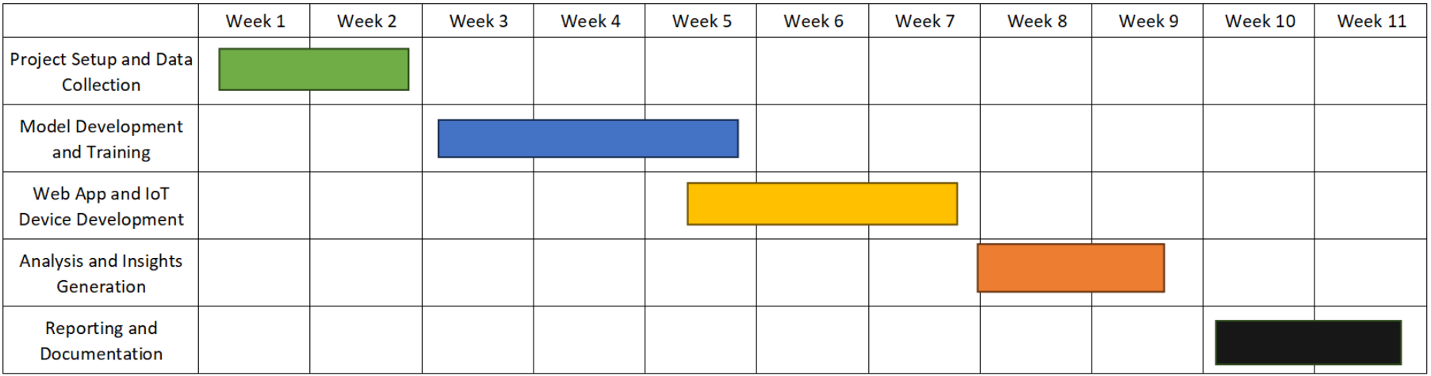

Figure 1 - Gantt Chart

# CHAPTER 2: LITERATURE REVIEW

## DEPENDANT VARIABLE

The dependent variable in this study is the "ideal crop suitable for that condition," or the outcome or impact that the research is attempting to predict or explain. Many climatic and soil factors, such as temperature, humidity, rainfall, and the concentrations of nitrogen (N), phosphorus (P), and potassium (K), determine the best crop selection. The primary objective of the research is to pick the best appropriate crop, since it is thought that these parameters have a significant role in determining which crops are most likely to thrive under particular conditions.

Since the dependent variable directly affects agricultural production, sustainability, and economic viability, its significance cannot be emphasized. Accurately determining which crop is most suited for a given set of circumstances can result in higher yields, more efficient use of available land, and more resistance to environmental stresses, all of which can further improve agricultural operations as a whole. The strategy used in this work, which predicts the optimal crop using machine learning models, offers a fresh and possibly revolutionary way to cope with the difficulties associated with agricultural decision-making.

This research attempts to find patterns and links between environmental and soil conditions and crop compatibility that might not be immediately obvious through conventional farming operations by utilizing historical data and machine learning algorithms. This might provide crop selection with a more data-driven foundation, which could result in notable gains in productivity, sustainability, and efficiency for the agricultural industry. In this case, identifying and analyzing the dependent variable is essential to verifying the efficacy of the machine learning models used and, eventually, to ensuring that the research successfully adds significant knowledge to the field of agricultural science.

There are many studies focused on this dependent variable, ideal crop suitable for a given condition. One such study looks at a big problem in southern Italy, where a harmful bacteria named Xylella fastidiosa subsp. pauca (Xfp) has caused a lot of damage to olive trees, which are very important there (Alhajj Ali et al., 2023). Since fighting these bacteria directly is tough, the researchers thought about replacing the sick olive trees with other kinds of fruit trees that wouldn't get sick from Xfp. They picked six types of trees that are either immune or resistant to Xfp: almond, fig, hazelnut, kiwifruit, pistachio, and pomegranate. They wanted to see which of these trees could grow well in the areas where the olive trees were dying. To figure this out, they used data about the climate and the soil and analyzed it with a computer system that helps map out data, called Geographic Information System (GIS). They looked at each area to see which of the six fruit trees could grow best there, considering the local weather and soil. The analysis showed that most of the land where olive trees used to grow could now be good for growing these new types of fruit trees, but how suitable they were varied a lot depending on the local conditions. Specifically, they found a lot of land was good for growing pomegranate, fig, and almond trees, in that order. Kiwifruit and pistachio also had some suitable areas, but hazelnut trees had the least suitable land available. This was the first time anyone tried to find a solution like this for the problem of Xfp in olive trees in southern Italy. The results are really helpful because they offer a way to fight the spread of Xfp by planting other types of trees that can bring in money and won't get sick from the bacteria. This could help keep farming going in these areas, despite the damage Xfp has done. Also, by choosing the right trees to plant in the right places, farmers can keep their land productive and valuable over the long term. The study also pointed out that this method of figuring out which trees to plant where could be a great tool for making smart decisions about how to use land in farming, especially in places where Xfp has hurt olive orchards a lot. By using this information, local leaders and farmers can make better choices about how to deal with the damage caused by Xfp, which could help reduce environmental and economic losses and keep the farming landscape diverse and healthy. The suggestions from this study could lead to better farming methods, help farmers make more money, and make the whole farming ecosystem more able to deal with problems like Xfp in the future.

In an insightful exploration into the intricacies of rice cultivation within Kurunegala district, Sri Lanka, a pioneering study leverages the capabilities of the Decision Support System for Agro technology Transfer (DSSAT) software, version 4.5, as delineated by Hoogenboom et al. (2008) (Dharmarathna et al., 2011). This advanced tool has been utilized to simulate the phenological progressions, growth patterns, and potential yields of four distinct rice varieties, under a set of specific soil nutrients and daily weather conditions prevalent throughout their respective growing seasons. The geographical focus of this study, the Kurunegala district, is characterized by its tropical climate, with daily mean temperatures oscillating between 28 to 30°C, coupled with an annual rainfall ranging from 1750 to 2500 mm, thereby presenting an ideal environment for paddy cultivation. The district's agricultural landscape is notably enhanced by its 25 major irrigation schemes, alongside a network of over a thousand village tanks and diversion-based storage irrigation systems, which collectively support the extensive rice farming activities in the area. The rice varieties selected for this study—namely Bg 250 (2 ½ months), At 307 (3 months), Bg 357 (3 ½ months), and Bg 379-2 (4 months)—were strategically chosen to encompass both short-term and long-term cultivation cycles, thus providing a comprehensive overview of the crop's adaptability to the district's climatic and soil conditions.

To ensure the reliability of the DSSAT model, a meticulous calibration and testing phase was undertaken, utilizing crop management data collected during the dry (Yala) seasons of 2006 and 2010. This preparatory step was crucial for affirming the model's accuracy in reflecting actual crop behaviors under varying environmental and managerial conditions. With the model duly calibrated and tested, it opens a window of opportunity for conducting in-depth analyses on future rice yield trends within the district. Moreover, it facilitates an understanding of how different management practices influence yield outcomes, enables the estimation of rice yields under a spectrum of soil properties, and aids in the formulation of adaptive strategies to mitigate the adverse effects of climate change on rice production. This study not only underscores the potential of utilizing sophisticated modeling tools like DSSAT in agricultural research but also exemplifies how such technologies can be instrumental in enhancing crop yield predictions, understanding variability in crop performance, and developing robust strategies for climate adaptation in rice cultivation. Through its findings, the research contributes valuable insights into the optimization of rice production practices in Kurunegala, potentially influencing agricultural policy and practice in similar climatic and geographical settings.

In another study, the goal is to forecast how future climate change may affect West Africa's suitability for cultivating particular crops (AbdelRahman et al., 2022). Eight distinct crops were examined, along with their potential outcomes in three distinct West African agricultural zones: Guinea, Sahel, and Savanna. They employed a crop suitability model called Ecocrop and the climatic projections from four global climate models to determine how crop growth conditions may change in a scenario of significant greenhouse gas emissions between 1960 and 2100. The majority of the crops the researchers looked at were well-suited to grow outside of the Sahel region, according to historical climate data, with a suitability index value (SIV) suggesting that the environmental circumstances were either appropriate or very suitable. Future climate models, however, indicate that growing temperatures may make it more difficult for crops like pineapple and cassava to thrive in the Guinea zone. Interestingly, the study also suggests that by the end of the century, maize might spread northward into the southern Sahel, providing additional opportunities for the cultivation of this crop. According to the study, despite climate change, mango and pearl millet will remain appropriate for production in all three agricultural zones. Nonetheless, it seems that crops in the Savanna region would be most affected by the anticipated changes in climate. This implies that there may be major obstacles to crop adaptability in West Africa in the future, which might have an effect on the region's food security. The study's findings emphasize how crucial it is to do further research on both short- and long-term adaptation techniques in order to get ready for these changes. This would lessen the detrimental effects of climate change on West African agriculture and guarantee that the continent can keep producing enough food to feed its people.

In another study, it is introduced an innovative method for evaluating the suitability of hemp crops to specific environmental conditions, employing a blend of experimental trials and simulation techniques (Baldini et al., 2020). Conducted in North-East Italy, the research assessed six hemp varieties over two years, focusing on dual-purpose production (seed and stem). The aim was to leverage these results to create and fine-tune a simulation model that can accurately predict how well hemp adapts to various cropping environments. The findings indicated that the biomass and stem yields from the hemp trials were comparable to those from similar experiments across Europe. However, seed production was slightly lower, which the study attributed to high temperatures (daily maximums exceeding 30°C) during the grain-filling phase, adversely affecting seed quality by limiting oil accumulation. The simulation model incorporated both existing literature and data from the current study to estimate key variables such as phenological parameters, the impact of water stress on seed production, and the relationship between temperature during the grain-filling period and seed oil content. A crucial component of this study was the use of historical meteorological data in a scenario analysis to forecast the effects of different irrigation regimes on several variables: seed yield, seed oil content, maturity date, and the total volume of irrigation required throughout the season. This analysis was tailored to the specific soil and climatic conditions of the trial site for each hemp variety. Through this methodology, the study provides valuable insights into predicting hemp crop performance in new regions, taking into account environmental factors and agricultural practices. The simulation model serves as a practical tool for farmers and researchers, enabling them to assess the adaptability and productivity of different hemp varieties in varying environmental conditions, thereby optimizing crop selection and management practices to enhance yield and quality.

In different research, the North-East region of Tunisia's land suitability maps for different crops under irrigation and rainfed circumstances were created and evaluated (Khouloud Abida et al., 2023). Vegetable crops, arboriculture (tree crops), and grains were among the crops examined. Using the Food and Agriculture Organization (FAO) classification and Free and Open-Source Geographic Information System (QGIS) tools, the methodology relied on arithmetic multiplication techniques while taking into account soil pedological qualities, slope, elevation, and climate data. The findings revealed a clear distinction in soil suitability for the different types of agriculture investigated. For cereals, the soils were generally classified as particularly suitable (S1) under both rainfed and irrigated conditions, with an improvement in suitability observed under irrigation (28.63% suitable). In contrast, arboriculture crops were found to be marginally suitable (S3) across the board, indicating a less favorable condition for tree crops in this region, with 20.44% and 23.71% of the area being suitable under rainfed and irrigated conditions, respectively. The study underscores the utility of GIS systems in assessing land suitability for agriculture, highlighting how specific crops fare differently under varying conditions. For the area studied, cereals emerge as a more viable option, especially under irrigated conditions, pointing towards the need for strategic improvements in land use and soil resource management to optimize agricultural productivity. This approach can be particularly useful in regions like North-East Tunisia, where agricultural productivity faces challenges from environmental degradation and climate change. By classifying land based on its capacity and suitability for various crops, stakeholders can make informed decisions on the best agricultural practices to implement, aiming to preserve soil functions and enhance sustainability in the face of these challenges.

Taiwan's food self-sufficiency problem, which has fallen below 40% as a result of dietary choices shifting away from rice and towards wheat and maize, is the subject of another research (Wang et al., 2023). Strategic crop planting distributions are becoming more and more important as Taiwan struggles with the effects of these shifting patterns of food consumption. In order to address this problem, a thorough examination of environmental and agricultural variables including soil quality, rainfall patterns, temperature fluctuations, irrigation availability, and soil erosion risks is included in the research's assessment of Taiwanese agricultural land's suitability for growing rice, wheat, and maize. Employing multi-criteria assessment, hierarchical analysis, and sensitivity analysis methods, the study generates crop suitability maps for rice, wheat, and maize across Taiwan. The findings reveal a general moderate to high suitability for rice cultivation throughout the island, with particularly favorable conditions in the southwestern regions. In contrast, wheat appears best suited to areas adjacent to hills in central, northwestern, and southeastern Taiwan, while maize cultivation is viable across much of the island, excluding coastal zones in the western plains. A crucial insight from the sensitivity analysis is the paramount importance of water availability during the growing season for all three crops, overshadowing the influence of temperature and soil characteristics. This underscores the critical role of irrigation in ensuring crop cultivation success. Despite the widespread suitability for rice cultivation across Taiwan, and the considerable areas amenable to wheat and maize growth, current agricultural practices do not fully capitalize on these potential cultivation zones. Wheat and maize, in particular, are cultivated in relatively confined areas, despite a significant proportion of the land being suitable for these crops. This discrepancy suggests a substantial opportunity to expand the cultivation of wheat and maize, aligning with the land's agroecological conditions. The study offers valuable insights for policymakers and agricultural planners in Taiwan, presenting a data-driven foundation for revising land allocation strategies to enhance crop diversification and sustainability. By aligning cultivation practices with the agroecological suitability of the land, Taiwan can take significant steps toward improving its food self-sufficiency rate and responding adaptively to shifts in dietary habits.

Another study uses Geographic Information System (GIS) and Analytic Hierarchy Process (AHP) methods to examine the appropriateness of several grain crops in Haryana, India (Shaloo et al., 2022). The optimal growth conditions for wheat, rice, sorghum, maize, and pearl millet are determined by taking into account many environmental elements, including temperature, rainfall, and soil texture. The research assigns an appropriateness level to land, using expert opinion to weight these aspects and ArcGIS for overlay analysis. The categories of suitability are extremely suitable, moderately suitable, and marginally suitable. Results show that most crops have a prevalent moderate suitability, indicating that by concentrating on these locations, agricultural output might be improved. Furthermore, increasing crop diversity in places that are just partly appropriate might help local farmers have more stable incomes.

In the flood prone Sirajganj area of Bangladesh, another such study focuses on crop suitability analysis for the Rabi (potato and wheat) and Kharif (rice and maize) crops in order to design an appropriate cropping pattern that reduces the impact of flooding (Haque et al., 2022). The study maps out locations ideal for certain crops throughout respective seasons by using the Analytical Hierarchy Process (AHP) to assess various soil and environmental parameters using GIS for weighted overlay analysis. According to the findings, 64.80% of the land is best suited for growing potatoes or wheat in the Rabi season and rice or maize in the Kharif season. Smaller portions may benefit from other combinations. This study not only pinpoints the best locations for certain crops based on flood risks but also contributes to more effective agricultural management planning in flood-prone regions.

Another research addresses the challenge of enhancing global food production amid climate change without harming the natural environment (Gardner et al., 2021). It focuses on improving crop suitability models by incorporating high-resolution microclimate data to identify optimal locations for diverse crops. This approach supports efficient land use and conservation efforts. Using the WOrld FOod STudies (WOFOST) mechanistic model, the study generates detailed crop yield projections based on microclimate datasets for the south-west UK, spanning 2012-2017 and 2042-2047. The results reveal significant yield variability over small distances, underscoring the value of precise climate assessments in agricultural planning to balance food production with biodiversity preservation. The study contributes by offering the WofostR R package, facilitating global application of this high-resolution modeling approach for current and future climate scenarios, thereby aiding strategic land-use decisions.

In another similar study, it delves into the anticipated impacts of climate change on root, tuber, and banana crops in the Great Lakes Region of Central Africa, where smallholder farming predominates (Manners et al., 2021). With a focus on understanding changes in crop suitability and planting dates, as well as identifying resilient crop varieties, the research aims to inform climate adaptation strategies and research investments in the region. Leveraging a modified version of the EcoCrop model, the study assesses the future suitability of four key crops and variant types under different climate scenarios. Results suggest a generally favorable outlook for root, tuber, and banana-based systems, with only potato facing widespread negative impacts. Notably, shifts in planting schedules and adoption of specific crop varieties tailored to local conditions emerge as promising adaptation strategies. By offering data-driven insights, this research lays a foundation for spatially targeted recommendations to support farmers and policymakers in effectively navigating climate change impacts and planning resilient agricultural systems for the long term.

Another study (Soberano et al., 2023) harnesses the power of machine learning and data mining techniques to evaluate and classify various algorithms for predicting soil suitability in Negros Occidental, Philippines. Leveraging experimental data and pattern extraction methods, the study assesses the effectiveness of Naive Bayes, Deep Learning, Decision Tree, and Random Forest algorithms in predicting soil suitability based on 14 parameters sourced from the Philippine Rice Research Institute. The results highlight the Random Forest algorithm's superior accuracy, achieving a remarkable 94.6% accuracy rate and a low classification error rate of 5.4%. Interestingly, the findings suggest that soil samples in the region are predominantly marginally suitable for crops like banana, maize, and papaya, with low fertility ratings posing significant challenges. This study not only provides valuable insights for local farmers to enhance soil management practices but also informs soil protection initiatives to address issues such as acidity and salinity, thereby fostering more sustainable agricultural practices in Negros Occidental, Philippines.

The Suitability software component plays a crucial role in evaluating the biophysical suitability of crops to agro-environmental conditions, serving as a vital tool in crop production studies (Confalonieri et al., 2013). By integrating various published approaches for computing crop suitability based on climate, soil, and crop data, Suitability enables users to assess the productivity potential of new crops and areas, as well as to evaluate potential cultivation shifts and crop adaptation needs under different climate change scenarios. The software offers two application programming interfaces (APIs) for single- and multi-cell estimations, with the latter employing multiple regression methods. Designed to be extensible by third parties, the component is released as a .NET 3.5 DLL, making it compatible with .NET client development. Additionally, a case study focusing on wheat suitability in Morocco demonstrates the practical application of the Suitability software component, showcasing its effectiveness in informing agricultural decision-making processes.

The important topic of climate change and its effects on agriculture is the subject of another study (Jayathilaka et al., 2012), which focuses in particular on Sri Lanka's main plantation crops—tea, rubber, and coconut. The study emphasizes crop adaptability and production potentials while conducting a regional evaluation of the consequences of climate change. Through the examination of data from six distinct agro-ecological zones between 1980 and 2007, the study produces georeferenced maps that demonstrate both temporal and geographical variations in crop production and suitability. Crop suitability maps are created for two different time periods (1980–1992 and 1993–2007) using the Analytic Hierarchy Process (AHP) in multi-criteria analysis. This enables the comparison of changes in suitability, yield, and climatic conditions.

## INDEPENDENT VARIABLE

The Independent Variables in this study are essential for determining if crops are suitable for a given set of environmental circumstances. We think that these variables—which include temperature, humidity, rainfall, phosphorus (P), nitrogen (N), and potassium (K)—may affect or forecast how suitable crops are for various environments. Comprehending the influence of these variables is imperative in order to enhance agricultural methodologies and augment crop productivity. We examine how each of these factors has been investigated in connection to crop development and production in this part by delving into the body of current literature. We look at the impact that temperature, humidity, rainfall, phosphorus, nitrogen, and other known factors have on crop performance, along with the underlying theories that support these effects. We want to have a thorough grasp of how these separate factors interact with crop cultivation and affect overall crop adaptability by synthesizing this knowledge.

One research paper introduces an innovative approach to enhance agricultural productivity by focusing on the optimal application of essential nutrients like Nitrogen (N), Phosphorus (P), and Potassium (K) - key elements that significantly influence crop health and yield (Ahmed et al., 2021). Given the critical role of these nutrients in supporting root development and overall plant growth, the study acknowledges the challenge of their variable needs across different crops and the global diversity in soil nutrient profiles. To tackle this challenge, the paper proposes a sophisticated method leveraging an improved genetic algorithm (IGA) combined with time-series sensor data to forecast the most effective nutrient mixes for a variety of crops. This approach aims to tailor nutrient recommendations precisely, thereby maximizing crop yield and ensuring efficient fertilizer use. The unique aspect of this method is its ability to dynamically adjust recommendations based on real-time soil and crop data, which significantly enhances the accuracy of nutrient application. The technique incorporates a neighborhood-based strategy for fine-tuning the optimization process, ensuring a balanced exploration of potential nutrient combinations and their exploitation to achieve the best possible crop yield outcomes. By comparing real-time sensor data with a database of optimal nutrient patterns, the algorithm can make highly informed recommendations that are closely aligned with the current state of soil fertility and crop needs. One of the key outcomes highlighted in the study is the potential of this model to improve soil fertility management and crop production over time. As soil fertility tends to decline due to continuous cropping and nutrient depletion, the proposed model serves as a critical tool for reversing this trend, offering precise nutrient supplementation strategies that can boost seasonal and annual yields. Experimental findings from the research demonstrate the effectiveness of the proposed model in optimizing nutrient patterns and enhancing crop yield efficiency. This approach not only helps in determining the most suitable regions for specific crops based on nutrient levels but also offers valuable insights into nutrient management strategies in the context of changing climate conditions.

In another paper, it is presented a novel approach to optimize regional crop water consumption by integrating a single-objective linear programming model with crop suitability considerations (L. He et al., 2018). The model accounts for various factors, including meteorological, topographic, and soil characteristics, in both the distributed water consumption model and the assessment of crop suitability. Applied to the middle reaches of the Heihe River basin in northwest China, the model generates optimal crop distribution and water consumption strategies for different hydrological conditions. Two optimization strategies are analyzed, one with fixed crop areas and the other with a fixed total planting area. Economic analysis reveals a significant increase in net income under both strategies, indicating the potential for improved economic returns. Despite a slight increase in water consumption, the unit water income and unit area income demonstrate substantial improvements compared to pre-optimization conditions. Overall, these findings provide valuable insights for guiding adjustments in planting patterns and sustainable irrigation water allocation plans.

The study (Manners et al., 2020) addresses the impact of climate change on the production potential of protein-rich crops in the European Union, aiming to fill a critical knowledge gap in understanding how climate variability might affect dietary protein sources. Utilizing the EcoCrop model and climate projections for the 2050s, based on 30 Global Circulation Models, the research analyzes 13 protein-rich crops under the Representative Concentration Pathway 4.5. The findings reveal a complex and heterogeneous pattern of climate change impacts on crop suitability across Europe. While northern regions show increased suitability for protein-rich crops, southern areas, traditionally conducive to crop cultivation, face limitations due to projected climatic shifts. Notably, there is an expansion in the suitability area for quinoa. The study underscores the importance of strategic breeding and research initiatives to enhance the resilience of crops like faba bean, lentil, and chickpea to anticipated abiotic stresses. Furthermore, it emphasizes the need for adaptive production planning and agricultural policies that align with emerging geographic patterns of crop suitability. By acknowledging and responding to these likely impacts, stakeholders can facilitate shifts in production practices and support the resilience of protein-rich crop cultivation amidst changing climatic conditions in the European Union.

Another study looked at how maize, a type of corn grown in Sri Lanka, does in different weather and soil treatments (Malaviarachchi et al., 2015). Maize hasn't been doing as well as it could because of problems like pests and tough weather. With the climate changing, these issues might get worse. The research was done in five places in Sri Lanka during the Maha season of 2012/2013 to see how maize reacts to temperature and soil care. They used three ways to manage the soil, including standard care, standard care plus covering the ground with mulch, and mulch with a mix of chemical and organic fertilizer. The study found that as it gets warmer, maize grows faster but doesn't do as well if it's too hot. The best temperature for maize to grow leaves and gain weight was around 23 degrees Celsius. Using mulch and organic manure helped the maize grow better and produce more compared to just the standard care. In places where it's usually warmer than the ideal temperature for maize, the study showed that the maize yield, or the amount harvested, dropped as it got even warmer. This means that if it keeps getting warmer because of climate change, maize might not do as well in Sri Lanka unless new kinds of maize that can handle the heat better are developed and used.

Another research compared soil quality and the productivity of maize and mungbean crops in fields and home gardens in a hilly area of Sri Lanka, looking at small-scale farming systems over two years. The study involved 30 farms, divided equally between fields and home gardens, across different slope categories: flat, moderate, and steep. On some farms, green manure was added using leaves from the Gliricidia plant. The study found that the soil in home gardens had at least 30% more organic matter than in fields, especially on flat land. However, after growing maize and mungbean for two years, the amount of soil organic matter (SOM) dropped, with a faster decrease in home gardens, which was linked to higher crop yields. When using recommended chemical fertilizers, maize always grew better in home gardens than in fields, except on steep lands without the chemical fertilizers. Maize yields were twice as high with chemical fertilizers compared to using just Gliricidia, reaching up to 4.5 tons per hectare on flat and moderate slopes, and 3.5 tons per hectare on steep slopes. This suggests that the lack of chemical nutrients was a bigger problem than the physical condition of the soil. Gliricidia alone didn’t help increase yields in fields but did boost yields by about 30% in home gardens compared to using no fertilizer at all. Mungbean yields were less affected by these treatments, though Gliricidia had a more significant short-term benefit for mungbean than for maize in fields.

long-term use of organic manure in home gardens led to higher productivity compared to fields managed more extensively. However, the benefits of annual green manure were mostly seen at lower levels of input and were surpassed by the effects of chemical fertilizers, regardless of the slope of the land. The study also showed that Gliricidia was helpful on degraded steep lands, but there's still a big risk of erosion. The recommendation was that farming on steep lands should switch to less slope-dependent methods, when possible, based on social and economic conditions.

In different research, the effects of variations in rainfall, relative humidity, minimum and maximum temperatures on the yields of maize, cassava, and yam per hectare of land in Ghana's Ashanti Region are examined (Dwamena et al., 2022). The study finds strong correlations between each climate element and agricultural productivity using correlation analysis. For every crop, multiple linear regression models that take into account the impacts of all meteorological factors are then created. The findings indicate that whereas higher minimum temperatures, in particular, result in lower yields of maize, higher maximum temperatures had the opposite effect on crop yields. Moreover, increased relative humidity levels have a negative effect on maize yields and decrease cassava yields. The regression models demonstrate that rainfall, relative humidity, minimum and maximum temperatures, and rainfall all have a significant influence on crop yield changes. They also explain 63.8%, 74.3%, and 64.2% of the differences in maize, cassava, and yam yields per hectare, respectively. The study emphasizes the significance of understanding and action about the consequences of climate change for agricultural production, based on these results. In addition to encouraging modern agricultural practices and the introduction of high-yielding crop varieties appropriate for shifting environmental conditions, it calls on Ghana's government, the Ministry of Food and Agriculture, and other agricultural stakeholders to step up their efforts in educating farmers about the effects of climate change. Ghana's agriculture industry may improve food security in the area and more effectively adapt to the problems posed by climate change by adopting these measures.

Another study examines the effects of temperature and precipitation variations on major crops in Pakistan, including sugarcane, wheat, rice, and maize. Warmer minimum temperatures are beneficial for all crops, but higher temperatures might negatively impact wheat productivity, according to research done between 1989 and 2015 (Ali et al., 2017). Rainfall generally reduces agricultural production, with the exception of wheat. It's critical to create new crop varieties that can withstand extreme heat and drought in order to address these issues brought on by climate change. Pakistan would be able to ensure that it has adequate food even during harsh weather in this way.

Rice fields in Taiwan are studied in another study. It examines how variations in weather and agricultural practices impact the development of crop diseases (Chiu et al., 2022). They used a sophisticated model and statistical techniques to study this over an extended period of time—roughly ten years. The temperature, humidity, wind, rainfall, and two agricultural practices—conventional farming and low-external-input farming, which uses less chemicals—were among the variables the researchers examined. They discovered that the impacts of both agricultural practices on the spread of rice blast, a prevalent disease, were comparable. They also found that high humidity was the only condition in which temperature exacerbated the illness. Up to a limit, rain had a beneficial effect on the illness; but excessive rain did not worsen it. Remarkably, they discovered that traditional farming and low-external-input farming, which employs less pesticides, had comparable impacts on the illness. Overall, the study indicates that when it comes to managing fungal infections in rice fields, weather variations may matter more than agricultural practices. Farmers can benefit from this research by being able to make more informed decisions about managing crop diseases under climate change.

In a separate study, the impacts of temperature, wind speed, relative humidity, solar radiation, and rainfall were examined in relation to oil palm output in Peninsular Malaysia (Abubakar et al., 2023). Even though oil palm is a widely grown crop throughout Southeast Asia and beyond, there have been difficulties with its production because of several elements such as weather and climate. Using statistical analysis tools like SPSS, the researchers were able to do descriptive statistics and multilinear regression (MLR) on the data. The MLR model aimed to assess the degree of correlation between different climatic parameters and oil palm yield. Remarkably, the study discovered that rainfall, solar radiation, relative humidity, wind speed, and temperature had minimal effects on oil palm yield and output. Approximately 20.2% of the fluctuation in palm oil production was explained by these climatic conditions, according to the research, suggesting that additional factors that were not taken into account in the study may also be important. The study suggests a comprehensive strategy that includes scientific research, the use of improved palm varieties, the promotion of regional leadership in agriculture, the engagement of both public and private stakeholders, partnerships with researchers in consumer countries, and the encouragement of growers to adopt best agricultural practices in order to improve oil palm production.

The effects of several climatic conditions on maize and sorghum production in the Plateau, Central, and Savannah areas of Togo, including temperature, sunlight, wind speed, and relative humidity have been studied in a separate study (Affoh et al., 2023). The researchers examined yields of maize and sorghum in addition to meteorological data from 1990 to 2019. To comprehend these linkages, they employed statistical techniques such as Chebyshev polynomial function and Fisher's meteorological regression. The findings demonstrated that across all locations and growth stages, rainfall tended to have a favorable effect on maize and sorghum yields. But temperature has varying effects on crops, sometimes helping and sometimes hurting them, particularly in the Savannah and Plateau regions. In the Central and Savannah areas, sunshine significantly increased maize output; however, in the Central region, it had the opposite effect on sorghum yield. Wind speed affected yields in both positive and negative ways, although it affected sorghum more significantly in the Savannah and Plateau areas. Additionally, relative humidity had conflicting results, having a favorable and negative impact on maize and sorghum yields at various phases and geographical areas. According to the study, it's critical to give farmers access to up-to-date agricultural meteorological data so they may better plan crop production and increase crop productivity.

The development and production of soybean crops were examined in another study in relation to climatic factors such as temperature, humidity, soil water content, and vapor pressure deficit (VPD) (Ogunkanmi et al., 2022). Different water and temperature conditions were used in their greenhouse experiment. High temperatures, they discovered, accelerated the crops' development, particularly during blooming. All the same, high temperatures also resulted in increased evapotranspiration and decreased photosynthesis, which significantly impacted the biomass and yield of the plants. When drought circumstances were coupled with high temperatures, soybean biomass and yield were much lower than when the temperature was normal, and the plants received adequate water. As a result of climate change, the study indicates that Ghana's soybean crop may be threatened by rising temperatures and erratic rainfall.

By creating ensemble learning models based on trees, another study seeks to improve crop adaptability and agricultural output, so supporting the 2030 Zero Hunger Agenda (Nti et al., 2023). The study builds and validates models on the relationship between crop production and environmental parameters such as potassium and rainfall using a publicly accessible Kaggle dataset. The results show that the model performed quite well, with a 99.34% F1-score, 99.39% recall, 99.32% accuracy, and 99.34% precision. By providing farmers with data-driven insights for the best crop choices, this thorough research advances global food security initiatives and supports sustainable agriculture practices.

In order to determine how climate change may alter the appropriateness of present production regions, another study evaluates the effects of climate change on the cultivation of three important tree crops in Southeast Asia: rubber, oil palm, and coconut (Appelt et al., 2023). Through the integration of agricultural cultivation data with estimates of climate change, the research makes predictions about major changes in crop adaptability under different scenarios. It concludes that prolonged dry spells and more precipitation would make insular Southeast Asia less suitable for oil palm and coconut farming, perhaps uprooting important crop regions. On the other hand, increasing temperatures would make rubber more suitable in continental areas and might allow rubber and coconut farming to move northward. However, the study also notes potential negative effects on local farmers and biodiversity, as shifts in crop suitability could lead to decreased yields and increased pressure on Key Biodiversity Areas.

Another study uses the RCA4 regional climate model to drive the Ecocrop model and simulations from 10 CMIP5 global climate models to evaluate the effects of climate change on crop suitability and planting months in West Africa (Egbebiyi et al., 2019). The study's analysis of the crop-climate departure shows varying effects for various crops and regions: a decrease in horticulturally appropriate areas in the Guinea-Savanna and an increase in cereal and legume production in the Sahel zone. The findings point to considerable changes in planting seasons, with most crops experiencing delays of 2-4 months; however, annual crops, such as plantains and pineapples, show minimal changes. This study offers vital information for creating methods of adaptation to protect food security against future changes in West Africa's climate.

Another study explores warming levels of 1.5°C, 2°C, and 3°C over the baseline of 1971–2000 in order to examine the impacts of global warming on crop suitability in West Africa (Egbebiyi et al., 2020). The Ecocrop model evaluated the adaptability of many crops, including pearl millet, cassava, groundnut, cowpea, maize, and plantain, using outputs from 10 CMIP5 GCMs downscaled by the CORDEX RCA4. The results show that areas appropriate for root crops and plantains in the middle Guinea-Savanna and for legumes and cereals in the centre southern Sahel are expanding northward. On the other hand, suitability declines beyond latitude 14°N, even if agriculture is still possible in these regions. Planting timings are expected to be one to three months later than expected, with notable differences based on the crop and area. The study underscores the pressing need for adaptive strategies in agricultural planning to enhance food security in response to climatic changes in West Africa.

## MODERATING VARIABLE

In the section on Moderating Variables, we delve into additional factors that could affect the relationship between the environmental and soil conditions (independent variables) and the suitability of crops (dependent variable). These factors, known as moderating variables, might include aspects like soil pH level or specific microclimate characteristics. Understanding these moderating variables is crucial because they can alter or influence how effectively the primary relationships being studied predict crop suitability. Through existing literature, we explore how these factors interact with the main variables under investigation, providing insight into the nuances of crop suitability in varying conditions.

Researchers used data from field and pot trials to conduct a meta-analysis in a study examining the effectiveness of lime addition in decreasing cadmium (Cd) contamination in crops grown in Cd-contaminated soil (citation of the article) (L. L. He et al., 2021). According to their investigation, applying lime raised the pH of the soil and reduced the amount of Cd that accumulated in crops. They found that the pH of the soil and the amount of Cd buildup varied depending on the kind of lime material used. It's interesting to note that pot trials showed a stronger effect of lime addition than field experiments did. The effectiveness of liming was also impacted by a number of soil parameters, including pH, organic matter concentration, cation exchange capacity (CEC), and clay content. Reduced baseline values for various soil properties tended to increase liming's advantages. Nevertheless, there were only modest impacts on lowering Cd accumulation in crops due to variables like trial design, crop kinds, and lime application levels. The effects of different forms of lime on the buildup of Cd also varied, with calcium carbonate (CaCO3) demonstrating the greatest influence. This study offers insightful information on the variables affecting how well liming works to raise soil pH and lower Cd contamination in crops produced in Cd-contaminated soil.

In another study conducted at Rothamsted Research, UK, researchers aimed to explore the relationship between soil pH and crop yield for various arable crops, focusing on the response to liming (Holland et al., 2019). They utilized data from Long-Term Liming experiments established in 1962, where four different rates of lime were applied, resulting in distinct soil pH levels ranging from 4.4 to 8.0. Over 35 years, the lime response was evaluated on several crops including spring barley, oats, beans, lupins, potatoes, linseed, oilseed rape, triticale, and wheat. Using relative yield (RY) and non-linear regression analysis, they assessed the effects of site, year, and phosphorus (P) fertilizer on the relationship with pH. The study found that liming significantly increased soil pH, although there was no consistent change in soil extractable P or exchangeable K. Site effects were significant for most crops, indicating differences in soil types between locations. Some crops, like spring oats and potatoes, showed weak responses to lime within the pH range tested. However, for crops like spring barley, triticale, wheat, and oilseed rape, the presence of P fertilizer influenced the yield-pH relationship, albeit with variations among crops and sites. The findings highlight the importance of Long-Term Liming experiments in enhancing understanding of the yield-pH relationship for key arable crops, with implications for crop selection in rotations. Additionally, the study identified the critical pH value for selected crops and detected the beneficial effect of fertilizer P in reducing this value, underscoring its role in optimizing crop production.

In a comprehensive study conducted over 36 years, researchers examined the impact of different phosphorus (P) application and liming rates on plant growth and soil P concentrations in Germany (von Tucher et al., 2018). The experiment involved a crop rotation of sugar beet, wheat, and barley, which are commonly cultivated crops in the region. The findings revealed that sugar beet exhibited greater sensitivity to low soil P and pH levels compared to wheat. Interestingly, wheat showed resilience even when P application was omitted over the long term. All three crop species demonstrated satisfactory growth even at soil P levels below the currently recommended thresholds, provided that soil pH was optimized through liming. This suggests that reducing P application rates can be effective in enhancing the efficacy of both soil and fertilizer P, as long as soil pH is adjusted to an optimal level specific to the soil type. These results underscore the importance of understanding the interactions between soil P, pH, and crop growth for sustainable crop production in regions with high plant-available P soils like Germany.

## UNDERLYING THEORY

The scientific ideas and concepts that explain how soil and environmental conditions affect which crops may grow in a certain place are further explored in this section. It is Important to understand that how plants respond to different weather conditions and take up nutrients from the soil. The goal is to demonstrate how these scientific theories contribute to our comprehension of why certain crops perform better in certain environments than in others.

Let's talk about the relationships between soil properties, crop growth appropriateness, and environmental factors. Soil conditions relate to the levels of nutrients, such as phosphorus (P), nitrogen (N), and potassium (K), in the soil. These nutrients are like food to plants; they are essential for development, synthesis of energy, and general well-being. The quantity of rainfall, temperature, and humidity that are usual for a place are all regarded as components of the environmental circumstances. It is well established that there is a relationship between soil nutrients and crop growth. For example, nitrogen is essential for the synthesis of chlorophyll, a green pigment used by plants in photosynthesis to make food. Phosphorus is necessary for the growth of roots and blooms, while potassium helps the plant stay healthy overall by enhancing its capacity to absorb water and ward off disease. However, environmental factors can have a significant impact. Plant growth and the germination of seeds require the proper temperature. Plants cannot grow healthily under extreme temperatures. Rainfall gives plants the water they require to grow and allows nutrients from the soil to seep into their roots. Rainfall levels that are too high or too low, however, can damage or even kill plants. Humidity may influence the spread of illnesses and has an impact on how much water plants lose to the air. After years of research, scientists have discovered that optimal crop development occurs when soil nutrients are balanced, and environmental factors are exactly perfect. This entails appropriate temperatures, precipitation levels, and humidity levels. Farmers may pick the best crops to cultivate in their region and how to manage their property to achieve the best harvests by being aware of these linkages.

## GAPS IN LITERATURE REVIEW

In agricultural research, there has been a lot of interest in examining the link between crop yield and the impact of environmental and soil conditions. Given its importance for maximizing crop yields by adjusting factors including phosphorus (P), potassium (K), nitrogen (N), rainfall, temperature, and humidity, this field of study is crucial. Even with the large amount of study devoted to comprehending these interactions, there is still a significant vacuum in the literature about the precise method of determining which crops are best suited for a given set of climatic circumstances.

Based on the reviewed investigations, diverse and inventive methods have been implemented to tackle distinct facets of crop-environment compatibility. For example, research on the effects of the Xylella fastidiosa subsp. pauca (Xfp) bacterium on olive trees carried out in southern Italy suggested replacing the afflicted olive trees with fruit trees that are immune or resistant to Xfp. The study found appropriate replacement crops using Geographic Information System (GIS) analysis, providing a unique solution to the Xfp problem by taking local soil and climatic variables into account.

Another study project used the Ecocrop model and climate forecasts to assess the possible influence on eight different crops in different agricultural zones in order to predict how future climate change will affect crop adaptability in West Africa. This study emphasized how crop adaptability may alter as a result of climate change, highlighting the significance of adaptation plans for maintaining regional food security.

An inquiry of the appropriateness of hemp crops was conducted in North-East Italy. The study included modelling techniques and experimental trials to forecast the performance of several hemp cultivars under changing climatic circumstances. This study offered information on how to best choose crops and manage them to improve yield and quality while taking environmental and agricultural practices into account.

Using GIS techniques and the FAO categorization, research conducted in the northeastern part of Tunisia evaluated the suitability of the land for various crops under irrigation and rainfed circumstances. The results showed that different soil types are more or less suitable for grains, cereals, and arboriculture, proving the value of GIS systems in determining land suitability for agriculture.

Finally, studies conducted in Taiwan examined the appropriateness of agricultural land for the production of rice, wheat, and maize in order to solve the issue of food self-sufficiency in the nation. The study produced agricultural suitability maps using multi-criteria evaluation, which showed prospects for crop diversification and sustainability in response to changing eating trends.

Nevertheless, although offering insightful information about crop-environment fit, these studies have not made use of machine learning (ML) approaches to improve the accuracy and productivity of their assessments. Furthermore, the Sri Lankan context, which offers particular possibilities and problems related to agriculture and the environment, has not been covered in any of these studies.

By using machine learning approaches to evaluate crop compatibility for particular environmental and soil conditions in Sri Lanka, our work seeks to close these research gaps. By doing this, we want to add to the corpus of knowledge with a cutting-edge strategy that uses machine learning to power precision agriculture and is especially adapted to the circumstances found in Sri Lanka. This method not only lays the groundwork for future studies in areas with comparable agricultural and environmental characteristics, but it also promises to provide more precise forecasts and useful insights for local farmers and politicians. We want to improve crop selection and management techniques through this project, which will ultimately help Sri Lanka's agriculture become more sustainable and productive.

## HYPOTHESIS DEVELOPMENT

One of the most important parts of our study is the Hypothesis Development portion, which connects theoretical knowledge with empirical investigation. After a thorough analysis of the literature, we have determined that a number of important variables, such as soil composition, environmental factors, and their interactions, affect crop adaptability. Our comprehension of these correlations has prompted us to put out a number of theories, using machine learning models to examine data gathered from different parts of Sri Lanka. Our theories aim to investigate the importance of these variables and how they interact, providing information that can guide the development of more productive farming methods. Our empirical inquiry will be guided by the following hypothesis.

Hypothesis 1: There is a significant relationship between NPK levels and the optimal plant growth across varying soil compositions. This hypothesis explores the direct impact of soil fertility, specifically the levels of nitrogen, phosphorus, and potassium, on plant growth, considering the variability in soil composition.

Hypothesis 2: Temperature variations significantly impact the choice of optimal plants to grow, moderated by soil composition. This hypothesis acknowledges the critical role of temperature in agriculture, suggesting that its impact on crop suitability is influenced by the nature of the soil.

Hypothesis 3: Humidity levels play a crucial role in determining the ideal plant species for cultivation, considering different soil compositions. With this hypothesis, we aim to understand how atmospheric moisture interacts with soil properties to affect plant growth.

Hypothesis 4: pH levels significantly influence the selection of plants for optimal growth, contingent on soil composition. This hypothesis examines the effect of soil acidity or alkalinity on plant health and productivity, and how this effect varies with different soil types.

Hypothesis 5: Rainfall patterns have a significant effect on the choice of plants best suited for growth, moderated by soil composition. This hypothesis explores the importance of water availability, as determined by rainfall, in conjunction with soil characteristics.

Hypothesis 6-10: These hypotheses investigate the interaction effects between soil composition and each of the factors (NPK levels, temperature, humidity, pH levels, and rainfall), suggesting that the relationship between these variables and plant growth is not linear but moderated by the overall soil composition.

Our study intends to provide insight on the intricate processes that govern crop suitability in Sri Lanka by thoroughly verifying these ideas. We expect to find patterns and links by utilizing machine learning techniques, which can help farmers and policymakers optimize agricultural productivity and sustainability.

# CHAPTER 3: METHDOLOGY

## THEORITICAL FRAMEWORK

The methodology's Theoretical Framework part describes the conceptual foundations of our research and provides an organized framework for comprehending the connections between crop suitability, environmental variables, and soil properties. Our study hypotheses are constructed using this framework, which also directs the choice of suitable approaches for data gathering, processing, and interpretation.

The fundamental tenet of our theoretical framework is that soil nutrients—specifically, nitrogen, phosphorus, and potassium—as well as environmental factors—such as temperature, humidity, and rainfall—all interact intricately to significantly affect crop growth and productivity. Our analysis is based on a vast body of literature that has been carefully explored in the context of agricultural science for each of these parameters.

**Key Components of the Theoretical Framework:**

1. Soil Nutrient Management: Soil nutrients have a direct impact on crop development and health and are essential to agricultural output. Based on agronomic concepts that connect nutrient availability to plant physiological processes, our framework highlights the crucial roles of nitrogen (N), phosphorus (P), and potassium (K) as main growth factors.
2. Environmental Influences: The framework recognizes that temperature, humidity, rainfall, and other environmental conditions have a critical influence in affecting agricultural yield and viability. In order to simulate how these variables affect crop development patterns and production potentials, it combines ideas from the environmental and agricultural sciences.
3. The Atmosphere-Soil-Plant Continuum: This part of the framework takes into account the relationships that exist between atmospheric conditions, plant development, and soil qualities. It emphasizes how crucial it is to comprehend the movement of energy, water, and nutrients along this continuum in order to promote the best possible development of plants.
4. Adaptation to climatic Variability: The framework includes techniques for crop selection and management procedures to adjust to changing climatic conditions, acknowledging the influence of climate change on agricultural activities. This involves choosing crop cultivars that can withstand variations in temperature and precipitation patterns better.
5. Machine Learning in Agriculture: Our study incorporates machine learning models as tools for crop suitability analysis and prediction, which is a unique complement to conventional agricultural frameworks. This element highlights how data-driven methods may improve agricultural decision-making by enabling the optimization of crop selections through thorough examination of soil and environmental data.

Our study is to methodically investigate the interactions between important agronomic parameters and their combined effects on crop adaptability using this theoretical framework. Through the implementation of a multidisciplinary approach that integrates components from environmental science, data analytics, and soil science, our aim is to offer practical insights that might facilitate sustainable and fruitful farming methods in Sri Lanka.

## POPULATION

"Population" in the context of our study on the best crops to grow in Sri Lanka under various environmental and soil conditions refers to all of the country's agricultural lands across all agro-ecological zones that could be suitable for the crops we are considering.

**Characteristics of the Population:**

1. Geographic Diversity: The population consists of agricultural areas that are dispersed throughout Sri Lanka's many geographical regions, including highlands, lowlands, and wet and dry zones. This diversity guarantees that a broad spectrum of soil types, climates, and environmental variables influencing crop suitability are included in the study.
2. Variability in Soil Properties: The population includes regions with a variety of soil properties, including differences in pH, texture, and the amounts of nutrients N, P, and K. In order to determine which crops are most suitable for a certain set of soil parameters and to evaluate how soil attributes impact crop growth, variety is crucial.
3. Range of Climatic Conditions: Because of Sri Lanka's diverse environment, which extends from tropical monsoon to subtropical temperatures, the country's population is representative of a broad range of temperature, rainfall, and humidity levels. This diversity allows for a comprehensive and comprehensive assessment of the numerous environmental elements influencing crop viability and output.
4. Agricultural Practices: The population also considers the various agricultural practices used in various locations, such as crop rotation strategies, irrigation systems, and traditional and modern farming techniques. Comprehending these methodologies is vital for evaluating the information in light of the existing farming systems and suggesting feasible crop selections.

The requirement to make sure that the results of our study are generally relevant to a wide range of agricultural scenarios in Sri Lanka justifies the selection of this diversified and thorough population. With a focus on diverse soil types, climatic circumstances, and farming techniques, our research endeavors to produce meaningful and practical insights for farmers, agricultural planners, and politicians nationwide. This strategy improves the generalizability of our findings and aids in the creation of resilient and sustainable agriculture practices that are flexible enough to adjust to Sri Lanka's shifting climate and environmental conditions.

## RESEARCH APPROACH

The general approach and methods used by the study to look into the research topic and hypotheses are described in this part. It outlines the logical flow that links the empirical results to the original goals and inquiries of the study. Our research strategy is multifaceted, combining quantitative analysis and computer modelling in the context of our study on applying machine learning models to determine the best suited crops for particular soil and climatic conditions in Sri Lanka.

Quantitative Research:

Our study primarily uses a quantitative research methodology. In order to comprehend patterns, correlations, and forecasts about crop suitability across various environmental and soil conditions, this entails the collecting and quantitative analysis of data. Variables including soil nutrient levels (N, P, and K), pH, temperature, humidity, and rainfall patterns may all be quantified with the use of statistical and machine learning methods, allowing for a methodical analysis of how these factors affect crop development and output.

**Computational Modeling:**

1. Machine Learning Models: The creation and use of machine learning models, particularly the random forest classifier, logistic regression, and decision tree classifier, is the foundation of our study methodology. These models are selected due to their resilience in classification tasks and their capacity to manage complicated datasets with several input variables. We hope to forecast the best crops for a given set of circumstances by training these models on past crop performance and environmental data, offering a valuable tool for agricultural planning decision-making.
2. Model Comparison and Selection: A key component of our methodology is evaluating the various machine learning models' performances according to F1 score, accuracy, precision, and recall. With the use of this comparison study, the best model or models for crop suitability prediction in various environmental situations will be determined.
3. Validation and Testing: Using distinct datasets that were not used during training, the models will go through a thorough validation and testing procedure. This stage is essential for evaluating how well the models can forecast crop suitability across various geographies and circumstances in Sri Lanka and how generalizable and reliable they are.

**Interdisciplinary Approach:**

Because it incorporates concepts from computer science, data science, agronomy, and environmental science, our research methodology is by its very nature multidisciplinary. Addressing the complex interaction of biophysical, environmental, and technological elements that determine agricultural output is contingent upon this integration.

The research strategy that has been selected is intended to meet the goals of the study by utilizing the advantages of both sophisticated computer methods and quantitative analysis. With the ultimate objective of increasing agricultural production and sustainability in Sri Lanka, this research attempts to provide insightful information about crop adaptability under various situations by methodically analyzing data and using machine learning models.

## MEASURES AND INSTRUMENTS

In particular, this section makes sure that the research technique is clear, reproducible, and compliant with high standards of scientific inquiry—all important considerations in a study using machine learning models and complicated datasets used to forecast crop suitability in Sri Lanka.

**Tools for Gathering Data:**

1. Soil analysis kits: These are used to determine the pH, potassium (K), phosphorus (P), and nitrogen (N) contents of the soil. These portable kits provide precise assessment of essential nutrients and soil acidity or alkalinity, which are critical for assessing soil fertility and health.
2. Climatic Data Loggers: Devices that record information on humidity, temperature, and rainfall. These methods provide the extensive, time-stamped environmental data needed to investigate the effects of climate on crop growth and productivity.
3. Remote Sensing Information: By using the Normalized Difference Vegetation Index (NDVI), satellite photos and remote sensing information can provide information on past crop performance, vegetation health, and larger-scale environmental conditions. For spatial analysis, this data is crucial and serves as a supplement to measurements made at ground level.

**Measurement Techniques:**

Soil Nutrient Analysis: Soil samples from different places are evaluated for pH, N, P, and K levels using soil analysis kits. To guarantee consistency and accuracy among samples, these measurements are made in accordance with established methods.

Climatic Measurements: To gather continuous data on temperature, humidity, and rainfall, climatic data loggers are positioned strategically across research sites. Understanding the micro- and macroclimatic factors influencing crop viability requires knowledge of these data.

Remote Sensing Analysis: To extract useful metrics on vegetation health, soil moisture, and other environmental factors impacting crop development, remote sensing data is processed and analyzed using sophisticated software tools.

Machine Learning Tools:

Data Preprocessing Tools: Data is cleaned, normalized, and organized using tools and libraries (like Pandas and NumPy for Python) before to being fed into machine learning models.

Modelling Software: To develop and assess models like logistic regression, decision tree classifiers, and random forest classifiers, the study makes use of machine learning packages like scikit-learn for Python.

Statistical Analysis Software: R or SPSS are two examples of statistical software that may be used to examine data distributions, correlations, and hypothesis testing in order to enable model evaluation and initial data analysis.

**Validation Instruments:**

Cross-validation Techniques: K-fold cross-validation techniques, which split the dataset into k smaller sets and test the model on one set while training on the others, are used to evaluate the generalizability and reliability of the machine learning models.

Performance Metrics: The main metrics used to analyses the machine learning models' performance are accuracy, precision, recall, and F1 score. These metrics offer a thorough evaluation of the models' prediction skills.

This thorough approach to measurement and instrument selection guarantees that the study's conclusions are supported by trustworthy, pertinent, and accurate data, increasing the research's credibility and usefulness in forecasting the best crops to grow in Sri Lanka under certain circumstances.

## DATA COLLECTION

The methodical procedure used to obtain the required environmental elements, soil composition data, and climate variables for the study is described in the "Data Collection" section. The sources of the data, sampling strategies, and steps taken to guarantee the accuracy and representativeness of the dataset used in the study are explained in this section.

**Data sources:**

1. Field Surveys: Field surveys were conducted all throughout Sri Lanka in order to collect soil samples from various agricultural sectors. These samples were analyzed in a lab to determine the composition of the soil, including the concentrations of nitrogen (N), phosphorus (P), potassium (K), and pH.
2. Government Databases: The meteorological data, which included temperature, humidity, and rainfall, was given by Sri Lanka's government meteorological services, who are in charge of monitoring and recording environmental elements throughout the nation. Acquiring historical data spanning several decades allowed for the capturing of long-term climate trends and variability.
3. Remote Sensing Information: To augment ground-level observations, reliable sources provided satellite photos and remote sensing information. These data sources offer insightful information about land cover, vegetation indices, and other environmental factors that are crucial to the research.

**Sampling Techniques:**

1. Stratified Sampling: Based on geographic locations, soil types, and land use patterns, sampling was stratified to guarantee representativeness. With this method, samples that are fairly dispersed throughout Sri Lanka's various agro-ecological zones may be chosen.
2. Random Sampling: To choose particular sites for the collection of soil samples and the measurement of climate data, random sampling procedures were used within each stratum. By using randomization, bias is reduced and the dataset's reflection of the larger population of interest is guaranteed.

**Data Collection Procedures:**

1. Soil Sampling: To ensure uniformity and accuracy across sampling locations, soil samples were taken according to established methods. To capture differences in soil composition and nutrient distribution, samples were obtained at many depths.
2. Climatic Data Measurement: Using calibrated equipment placed at key sites around the research region, meteorological data, such as temperature, humidity, and rainfall, were measured. To capture temporal variability, data loggers were set up to collect readings at predetermined intervals.
3. Acquisition of Remote Sensing Data: High geographical and temporal resolution was ensured by obtaining satellite images and remote sensing data from reliable sources. Specialized software tools were used to analyses this data and extract pertinent environmental factors for investigation.

**Quality Assurance:**

1. Calibration and Standardization: To guarantee measurement accuracy and dependability, all data gathering instruments were calibrated and standardized in accordance with accepted methods.
2. Data Validation: Strict validation methods were used to the gathered data in order to find and correct any flaws or discrepancies. Anomalies and outliers were marked for additional study and possible removal from the dataset.
3. Data Security: Steps were taken, such as encryption, backup plans, and controlled access to critical data, to guarantee the security and integrity of the data that was gathered.

The study guarantees that the dataset used for analysis is strong, dependable, and appropriate for guiding the creation of prediction models to find the most suited crops for certain climatic circumstances by upholding strict data gathering protocols and quality assurance mechanisms.

## DATA ANALYSIS

**Statistical Analysis:**

1. Descriptive Statistics: Measures of central tendency and dispersion were computed as descriptive statistics in order to list the characteristics of the dataset. The averages, standard deviations, and frequency distributions of the soil composition variables (N, P, and K), meteorological variables (temperature, humidity, and rainfall), and other relevant parameters must be calculated.
2. Correlation Analysis: The relationships between the different variables in the dataset were assessed using this technique. Pearson correlation coefficients were calculated to examine the direction and strength of correlations between crop suitability indicators, weather, and soil composition.

**Machine Learning Modeling:**

1. Feature Engineering: To prepare the dataset and extract pertinent characteristics for modelling, feature engineering approaches were used. To make sure that machine learning algorithms work with the variables, this involves scaling, normalizing, and transforming them.
2. Model Selection: depending on their capacity to forecast crop compatibility depending on environmental circumstances, three classification algorithms—the Random Forest Classifier, Logistic Regression, and Decision Tree Classifier—were chosen. The robustness, interpretability, and capacity to manage nonlinear interactions of these models led to their selection.
3. Model Training: A portion of the preprocessed dataset was reserved for training, while the remaining amount was used for validation. This made it possible to train the selected machine learning models. Hyperparameter modification techniques were employed to optimize the performance of every model and prevent overfitting.
4. Model Evaluation: Recall, accuracy, precision, and F1-score were a few of the appropriate metrics utilized to evaluate the effectiveness of each machine learning model. Cross-validation techniques were used to assess the models' generalization ability and ensure consistency across several datasets.

**Hypothesis Testing:**

1. Null Hypothesis Testing: To evaluate the viability of the proposed hypotheses, hypothesis testing was done. To ascertain if the observed connections between crop adaptability, climatic conditions, and soil composition were statistically significant, statistical tests such as ANOVA and t-tests were conducted.
2. Effect Size Analysis: To quantify the observed effects and ascertain their practical importance within the study's context, effect size measures such as Cohen's d and eta-squared were computed.

**Sensitivity Analysis:**

1. Variable Importance Analysis: Sensitivity analysis methods were used to determine which factors had the most influence on how well the machine learning models predicted the future. This aids in ranking the variables that most affect crop suitability forecasts.
2. Robustness Assessment: Robustness tests were performed to evaluate the stability and dependability of the model predictions under various conditions and assumptions. To assess the robustness of the findings in relation to input variables and model parameters, a sensitivity analysis was carried out.

The "Data Analysis" section provides a comprehensive technique that combines statistical analysis, machine learning modelling, and hypothesis testing to provide actionable insights and direct agricultural planning and crop selection decisions in Sri Lanka.

# CHAPTER 4: BACKGROUND OF THE STUDY

## WHAT IS IT

Farming accounts for a significant portion of Sri Lanka's GDP. For the majority of people in the area, farming is their main source of income. However, a lot of factors impact farming's potential for success, including the kind of soil, the climate, and the best crops to plant. In order to guarantee food supply and maximize farming operations, it is imperative to comprehend the relationship between these components. Soil is essential to crop growth. For a healthy growth, plants require the proper elements, such as nitrogen, phosphorus, and potassium. The weather is an additional important aspect. Weather conditions such as temperature, humidity, rainfall, and others can affect how quickly crops develop. Farmers must take into account each of these considerations when deciding what to plant. Finding crops that do well in specific conditions is essential to farming success. Because of variables like weather and soil composition, certain crops thrive in particular locations while others do not. Farmers can produce more food and protect the environment by learning which crops do well in different conditions. Hence, the purpose of this study in Sri Lanka is to examine the interactions between various crops, the soil, and the climate. Utilizing sophisticated computer programmers, they will be able to comprehend how every factor influences crop growth. In order to help farmers make better decisions about what to cultivate and how to care for their land, more knowledge on what causes crops to grow properly is sought after.

The goals of the study are as follows: Initially, they want to investigate the impact of soil on crop suitability in various regions of Sri Lanka. After that, they'll examine how factors like humidity, rainfall, and temperature impact crop growth. In order to forecast which crops would perform best in various soil and weather circumstances, they will also utilize sophisticated computer programmers. Lastly, they will use their findings to provide guidance to farmers so they may increase food production and improve land management. For those who make choices regarding farming in Sri Lanka, this study is crucial. The research can help farmers maintain their property and produce more food by learning more about what factors contribute to healthy crop growth and how they respond to adverse weather conditions. In the end, the goal is to ensure that farming in Sri Lanka continues to be prosperous and sustainable.

## WHY IT IS IMPORTANT

For farmers in Sri Lanka, it is crucial to understand the ways in which various crops interact with the land and climate. Farmers may choose more wisely what to plant and how to care for their property if they are aware of which crops thrive in particular environments. This increases their food production and safeguards their land for future generations. Furthermore, by gaining a deeper understanding of how crops react to various environmental conditions, agricultural specialists and politicians can create more effective plans to assist farmers and guarantee food security in Sri Lanka. Thus, the importance of this study lies in its ability to sustain the nation's total food supply, preserve the land, and assist farmers in producing more food.

## LIST OF ALL USER REQUIREMENTS

* 1. EXPLANATION OF THE CURRENT SYSTEM

When there isn't a certain system in place to talk about, it's important to look at the many studies and study findings that the literature review highlights. These studies provide important insights into the relationships between several parameters, including crop suitability, soil composition, and climate. We may learn more about the intricacies of agricultural systems and the difficulties farmers have in maximizing crop yield by looking at this research.

One research, which emphasized the significance of adjusting to environmental risks, concentrated on finding substitute fruit trees that might flourish in regions impacted by the Xylella fastidiosa subsp. pauca (Xfp) bacterium in southern Italy. Different research looked at how crop adaptability may be affected by climate change in West Africa, highlighting the necessity of taking preventative action to lessen negative consequences on food security. The adaptability of hemp crops under various climatic circumstances was also investigated in study conducted in North-East Italy, highlighting the need of taking environmental aspects into account when choosing and managing crops. Moreover, research carried out in Taiwan and Tunisia evaluated the appropriateness of the land for various crops, highlighting the importance of soil and climate factors in influencing agricultural output. These studies underscore the significance of taking into account a variety of elements in crop planning and management, and they offer insightful information on the intricacies of agricultural systems.

While these studies provide insightful information on particular elements of crop compatibility and environmental interactions, a thorough knowledge of how these factors interact to affect crop yield and growth is still lacking. By analyzing the interactions between soil composition, climate, and crop adaptability in Sri Lanka, the current study aims to close this gap. Through the integration of extant research findings and the use of sophisticated analytical methodologies, the objective of this study is to furnish a comprehensive comprehension of Sri Lankan agricultural systems and facilitate evidence-based decision-making for sustainable crop production.

## DRAW BACKS OF THE CURRENT SYSTEM

Upon examining the current body of literature, a number of shortcomings and restrictions emerge, emphasizing the areas in need of more study and development. The absence of thorough research that incorporate many aspects impacting crop adaptability and agricultural production is one of the main disadvantages. Numerous studies now in existence concentrate on certain elements, such the makeup of the soil or the temperature, without taking into account the intricate relationships between these variables. This disjointed approach makes it more difficult to comprehend the larger agricultural environment and prevents the creation of comprehensive crop management plans.

The restricted geographic scope of many studies, which frequently concentrate on certain areas or nations, is another disadvantage. Even while these studies offer insightful information on regional agricultural systems, it's possible that they can't be applied to other areas with dissimilar farming techniques and environmental variables. The limited generalizability of study findings highlights the necessity for more inclusive and varied studies that cover a wider range of geographic situations. Moreover, methodological flaws or insufficient data may restrict some of the previous research. Reliance on outdated climate data or oversimplified modelling techniques, for instance, may restrict the accuracy of forecasts by ignoring subtleties in environmental dynamics. Furthermore, variations in the quality and availability of data between geographical areas may inject biases or uncertainties into study findings, compromising the validity and robustness of conclusions.

Furthermore, there could be a disconnect between research results and actual application in agricultural policy and management. Effective communication and information transfer processes are necessary to translate research findings into practical solutions for farmers and policymakers, even though these insights and suggestions may be helpful. To guarantee that scientific discoveries translate into advances in agricultural production and sustainability in the real world, it is imperative to close this gap between research and practice. Overall, there are a number of issues and limits that need to be resolved even if the literature now in publication offers insightful information on a variety of crop adaptation and environmental interaction topics. We can improve the resilience and sustainability of crop production globally and deepen our understanding of agricultural systems by recognizing these flaws and striving for more inclusive, thorough, and practically applicable research methods.

## EXPLANATION OF THE PROPOSED SYSTEM

By taking a thorough and integrated approach to researching crop adaptability and agricultural production, the suggested method seeks to overcome these shortcomings in contrast to the limits of the literature that is currently in publication. The suggested system strengthens the base established by earlier studies while addressing its flaws with creative approaches and comprehensive viewpoints. The integration of several parameters impacting crop growth, such as soil composition, meteorological variables, and crop traits, forms the fundamental basis of the suggested system. The suggested method tries to reflect the many linkages and feedback loops that create agricultural systems by taking these elements into account collectively rather than separately. A more detailed knowledge of crop compatibility and resistance to environmental stresses is made possible by this holistic approach, which makes it easier to build resilient and flexible agricultural policies.

Additionally, the suggested system makes use of cutting-edge analytical methods, namely machine learning algorithms, to examine sizable and diverse datasets. The system may identify patterns and associations that might not be seen using conventional statistical approaches by utilizing machine learning. Informed decisions on crop selection and land management may be made by farmers, policymakers, and other stakeholders with the help of this data-driven method, which produces more accurate predictions and actionable insights. Significantly, the suggested approach places a strong focus on generalizability and scalability with the goal of producing results that can be applied to a variety of farming systems and geographic situations. In order to provide insights that are applicable and adaptable to a broad range of agricultural situations, the system conducts research in several locations and incorporates data from diverse sources. By taking a more comprehensive approach, research findings become more useful and significant, supporting international initiatives to increase food security and agricultural sustainability. All things considered, the suggested system signals a paradigm change in agricultural research towards more integrated, data-driven, and multidisciplinary methodologies. Through the adoption of novel approaches and resolving the shortcomings of current literature, the suggested methodology has the potential to revolutionize our comprehension of crop adaptability and improve agricultural practices.

# CHAPTER 5: FEASIBILITY STUDY AND REQUIREMENTS GATHERING

## FEASIBILITY STUDY

### COST FEASIBILITY

The cost feasibility analysis for this study includes Net Present Value (NPV), Return on Investment (ROI), and Payback Period analysis. The initiative minimizes the initial financial expenditure by using open-source machine learning frameworks and off-the-shelf IoT devices. When it comes to entrance barriers, these affordable technologies are less of an obstacle than more conventional agricultural monitoring systems. Based on early data, the NPV calculation will combine projected cash flows from improved yields and greater agricultural efficiency against project expenditures, indicating a promising future. A positive return on investment is expected, given the minimal initial costs and substantial advantages of optimal plant culture. The payback period is expected to be short, given the minimal upfront costs and the quick realization of benefits through improved crop yields and resource utilization.

### TIME FEASIBILITY

The project's schedule is organized around significant checkpoints, such as the phases of testing, machine learning model creation, sensor deployment, and data gathering. IoT and machine learning technologies are ready and accessible, allowing for a quick start. The project schedule takes into consideration iterative testing and improvement cycles to guarantee timely execution. According to preliminary evaluations, the project may go from idea to initial deployment in less than a year, with continuous modifications and enhancements made as real-world data is gathered and examined.

### SCOPE FEASIBILITY

The project's scope is clearly defined; it centers on applying machine learning and IoT to improve plant cultivation. The scalability of the system, which can be tailored to various plant species and agricultural contexts, emphasizes its viability. The project's needs are met by the availability of IoT technology and machine learning technologies, which keeps the scope realistic and reachable. Moreover, partnerships with agricultural specialists guarantee that the project stays in line with industry requirements and procedures, making the scope both applicable and manageable.

### TECHNICAL FEASIBILITY

Because machine learning algorithms and Internet of Things sensors are readily available and mature, this concept has a high technological viability. This project has a strong basis since the technology required for data collection and analysis is easily accessible and has been tested in a variety of non-agricultural applications. The project team has the skills or access to the necessary resources to deploy sensors, process data, and create predictive models. Although acknowledged, the technical difficulties in sensor calibration, data integration, and model correctness are seen to be doable given the state of the art in terms of technology and procedures.

## REQUIREMENTS GATHERING

### SELECTING THE SUITABLE FACT GATHERING TECHNIQUE

For our project, selecting the right method to gather information was crucial. We needed accurate and comprehensive data from different parts of Sri Lanka to make our system effective. After considering several methods, we decided that visiting various areas across Sri Lanka would be the best approach. This direct method allowed us to collect real-time environmental data and understand the specific needs and challenges faced by farmers in different regions. We had the benefit of witnessing the circumstances firsthand by travelling to several locations. In addition to seeing the environmental elements influencing plant development and gathering pertinent soil and climatic data for our study, we could have direct conversations with the farmers. While this method required more time than others, such as questionnaires or online data collecting, it guaranteed the relevance and correctness of the information we acquired. We were able to establish contacts with nearby farmers and agricultural specialists thanks to this practical approach, which is helpful for obtaining sincere comments and ideas. Through these exchanges, we were able to gain a thorough grasp of the real-world difficulties facing the agricultural industry, which is essential for creating solutions that work. By choosing this method, we aimed to ensure that our system would be built on a foundation of reliable, firsthand information, making it as effective and applicable as possible for improving agricultural practices in Sri Lanka.

### FACT GATHERING USING SELECTED TECHNIQUES

After selecting visiting different areas of Sri Lanka as our primary fact-gathering technique, we implemented a structured approach to ensure comprehensive and effective data collection. This involved planning our visits to cover a wide range of agricultural zones, ensuring we gathered data representative of the diverse climates and soil types across the country. We used a list of prepared questions to interview local farmers during our trips in an effort to learn as much as possible about their farming methods, obstacles they have faced, and farm environment. These exchanges not only gave us useful information, but they also promoted more honest and open conversation by helping us establish confidence in the community. Additionally, we collected real-time environmental data from each location, including temperature, humidity, and soil pH levels, using portable IoT devices. We were able to confirm the farmers' information and obtain a more accurate knowledge of the regional factors influencing agricultural output thanks to this direct assessment. To complement our field data, we engaged with agricultural experts and researchers in each area. These discussions enriched our findings with professional insights into the impacts of environmental factors on plant growth and the potential benefits of implementing IoT and machine learning solutions in agriculture. This multi-faceted approach ensured that our fact-gathering process was thorough and effective. By combining direct observations, environmental data collection, and expert consultations, we were able to compile a comprehensive dataset that forms the backbone of our project. This data is crucial for developing an accurate and reliable system that can significantly improve agricultural practices in Sri Lanka.

### REQUIREMENTS DETERMINATION

#### CORE REQUIREMENTS

Our project's fundamental needs are necessary for the system we want to build to function as a whole. These specifications directly stem from the main goals of using IoT and machine learning technology to improve plant farming operations.

**Integration of IoT Sensors:** The system must be able to interface with a variety of IoT sensors in order to collect data in real time on environmental factors including temperature, humidity, soil pH, and nutrient levels.

**Data Processing and Management:** A robust framework for data processing and management is necessary to handle the huge volumes of data collected from the sensors and guarantee data integrity and security.

**Creation of Machine Learning Models:** In order to forecast ideal growing circumstances and possible yield results, the system has to create machine learning models that can analyze sensor data.

**User Interface:** An easy-to-use interface that enables farmers and agricultural specialists to engage with the system and receive data visualizations, cultivation guidance, and forecasts.

**Flexibility and Scalability:** The system's design has to be both flexible enough to accept a range of crops and versatile enough to adapt to various agricultural settings and methods.

* + - 1. SECONDARY REQUIREMENTS

Secondary criteria contribute to the system's overall effectiveness and adoption by supporting the improved functionality and user experience.

**Mobile Application:** A mobile application that makes the system's capabilities, including as alerts, notifications, and real-time data updates, easily accessible to farmers.

**Customizable Reports:** Users may create reports that are specifically suited to their unique cultivation circumstances and procedures, highlighting important insights and offering advice.

**Offline Functionality:** The mobile application has some offline functionality that lets users access important data even in places with spotty internet access.

**Community Forum:** An integrated online community forum where farmers can share experiences, seek advice, and discuss best practices with peers and experts.

**Training Modules:** Development of training modules and digital tutorials to educate users on leveraging the system for improved agricultural outcomes, including guidance on interpreting predictions and implementing recommended practices.

### RESOURCE IDENTIFICATION

#### HARDWARE

For the successful implementation of our project, the following hardware resources are identified as crucial.

**Computing Power:** We need computers with a lot of processing power to handle large amounts of data, train models, and perform intricate analysis quickly. For machine learning operations, these machines need have a large amount of storage space, a high RAM capacity, and a robust CPU speed to handle the volume of data.

**Arduino Boards:** Our method for integrating with IoT sensors is based mostly on the usage of Arduino boards. These boards will enable the real-time collection of environmental data from the field and their subsequent transfer to our backend systems for additional processing and analysis. The dependability, adaptability, and interoperability of Arduino boards with a broad variety of IoT sensors make them the preferred choice.

#### SOFTWARE

We have selected a variety of programming tools, libraries, and environments that are necessary for our project based on their efficacy in data analysis, machine learning model creation, and data visualization:

**Python:** The main programming language, Python has a lot of support for backend development, machine learning methods, and data analysis. Because of its extensive library environment and ease of reading, it is the perfect option for our project.

**Jupyter Notebook:** Jupyter Notebooks will be used for experimentation, interactive coding sessions, and recording of the coding process. Documents with live code, mathematics, graphics, and narrative prose may be created and shared using this online application.

**Data Collection Libraries:** For effective data collection, manipulation, and preparation, libraries like pandas for data analysis and manipulation, numpy for numerical calculations, and requests for submitting HTTP requests are necessary.

**Machine Learning Libraries:** For more complex models, such as Long Short-Term Memory networks (LSTM), TensorFlow or Keras will be utilized, and scikit-learn for a range of regression and classification tasks.

**Data Visualization Libraries:** Two libraries that will be used to produce educational plots and visualizations that help with understanding the data and the model results are Matplotlib and Seaborn.

## THE SOFTWARE PROCESS MODEL

1. CHAPTER 6: DOMAIN INVESTIGATION

In-depth examination of domain-specific instruments and theoretical frameworks that serve as the foundation for performing technical research and making well-informed business decisions is covered in this chapter. The main focus is on comprehending and utilizing decision theory concepts and decision support tools. We also go further into technical research pertinent to our project's goal of improving plant cultivation techniques through the use of IoT and machine learning.

## DECISION SUPPORT TOOLS (business decisions)

Decision support technologies are essential for optimizing plant cultivation and monitoring. These technologies support the interpretation of intricate data, forecast results, and direct the formulation of wise business judgements. The utilization of decision support tools is particularly pertinent in situations involving a multitude of intricate factors, as is often the case in agricultural settings.

### DECISION THEORY

A framework known as decision theory helps people make rational judgements based on statistical data and relevant knowledge. In order to analyze scenarios where decision-makers must select between several tactics in order to maximize efficiency or minimize risk, it blends probability theory, statistics, and game theory. Decision theory will inform the selection of machine learning models, best practices for data collecting, and deployment strategies for Internet of Things sensors in our project.

### DECISION TREE

One such decision assistance tool that exemplifies decision theory is the Decision Tree. It is a graphical depiction of several option routes and their potential results, such as utility, resource costs, and chance event occurrences. It's very helpful for our study in assessing how well various methods of data collecting, model selection, and sensor placement work. Decision trees aid in determining the best course for optimizing resource allocation and obtaining high predictive modelling accuracy.

## TECHNICAL RESEARCH

Our project's technical study includes a thorough examination of the most recent developments in machine learning algorithms, IoT technologies, and their suitability for use in agricultural environments. This includes:

**Exploring IoT Sensor Technologies:** Examining the accuracy, dependability, and system integration potential of several sensor types appropriate for monitoring environmental parameters and plant health indicators.

Machine Learning Models for Agriculture: Examining the literature currently available on the use of machine learning in agriculture, with a focus on predictive analytics for monitoring soil health, disease prediction, and crop production. This involves assessing several algorithms for their effectiveness within our particular situation.

**Data Processing and Analysis Techniques:** Investigating effective ways to handle and examine the massive volumes of data gathered by Internet of Things sensors. This covers methods for preparing, cleaning, and altering data so that machine learning models may be used with it.

**Sustainability and Environmental effect:** Taking into account both the environmental effect and sustainability of the suggested solutions. This entails evaluating how much energy Internet of Things devices use, calculating the carbon footprint of widely implementing such technology, and making sure the solutions are environmentally benign.

**Technical Scalability and Security:** Examining how scalable the suggested fixes are in order to support extensive implementations in various agricultural contexts. In order to make sure the system is resilient against attacks; it is also important to evaluate the security implications of Internet of Things devices and data privacy issues.

The domain investigation aims to build a solid foundation of knowledge and insights that will inform the development of a highly effective, efficient, and sustainable system for optimizing plant cultivation practices. By integrating decision support tools with in-depth technical research, the project seeks to navigate the complexities of modern agriculture, leveraging technology to address its challenges.

1. CHAPTER 7: DESIGN

## DESIGN OVERVIEW

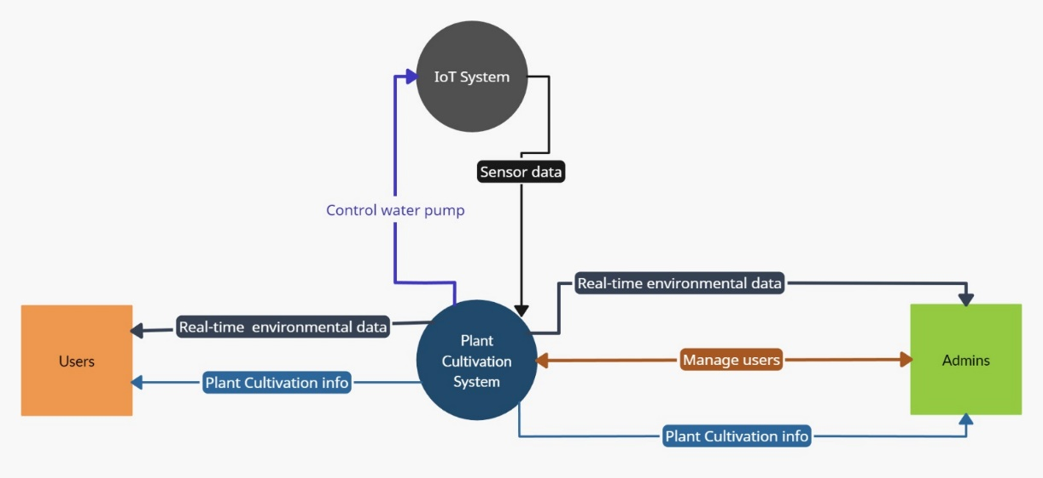

Figure 2 - Design Overview for the System

## DESIGN OF THE SYSTEM

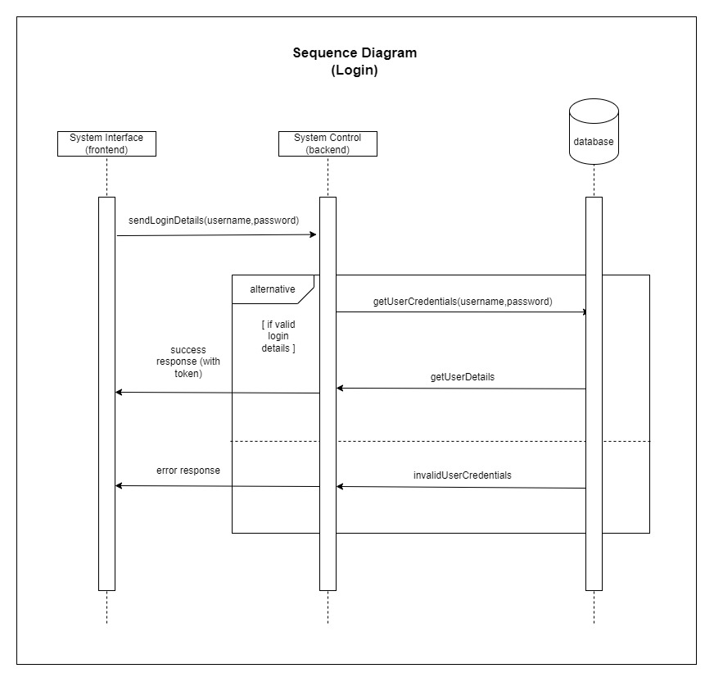Figure 3- Sequence Diagram for the Login Function

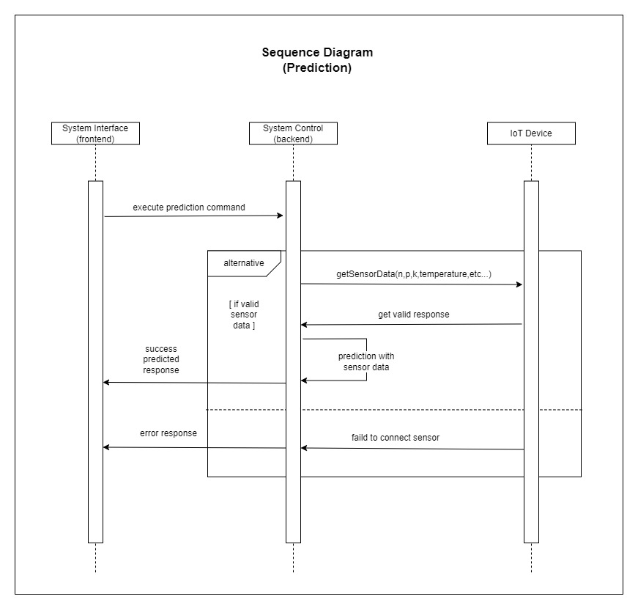

Figure 4 - Sequence Diagram for the Prediction

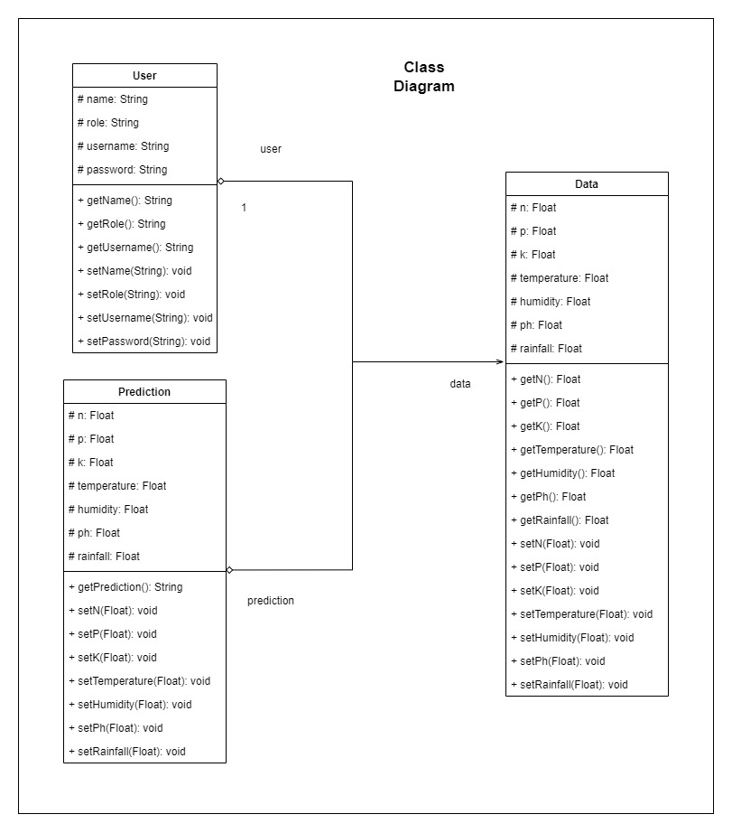  
Figure 5 - Class Diagram for the component

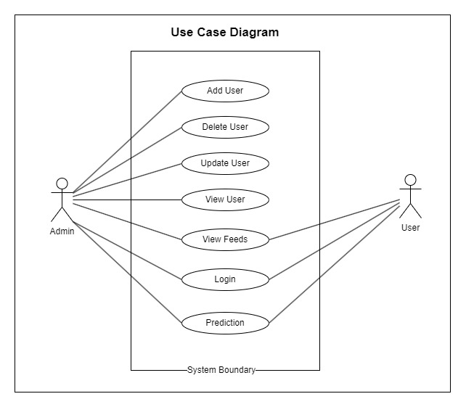Figure 6 - Use Case Diagram

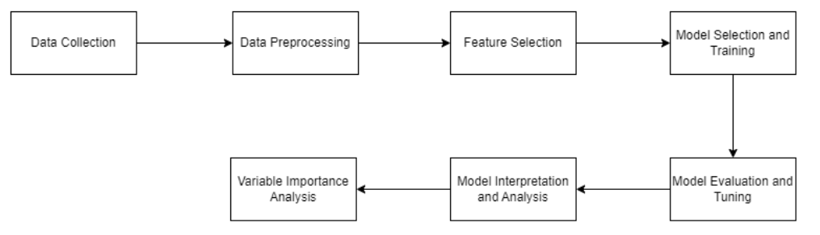

Figure 7 - System Process workflow of the Machine Learning Model

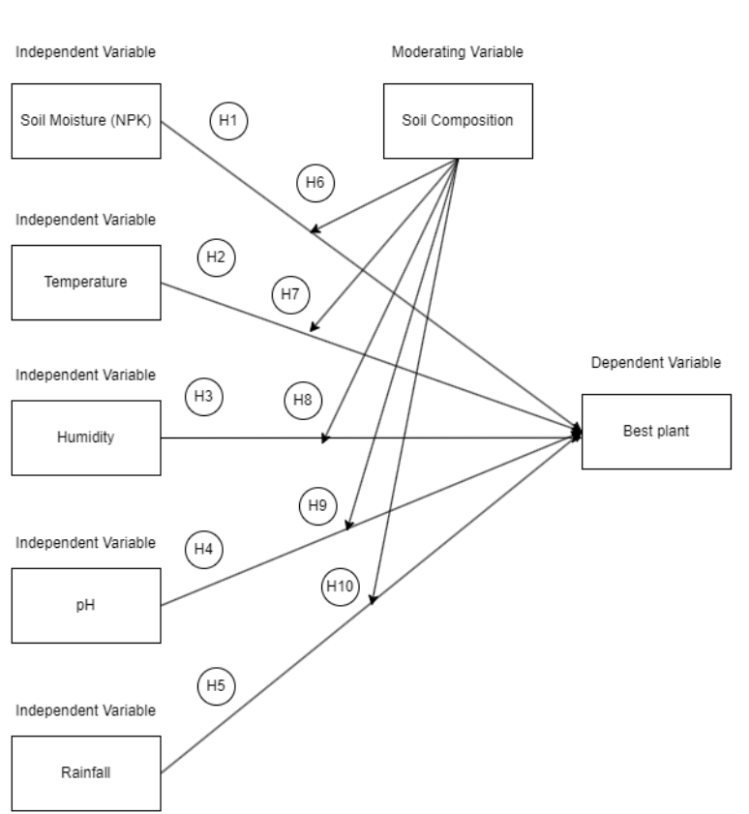

Figure 8 - Conceptual Framework and Hypothesis

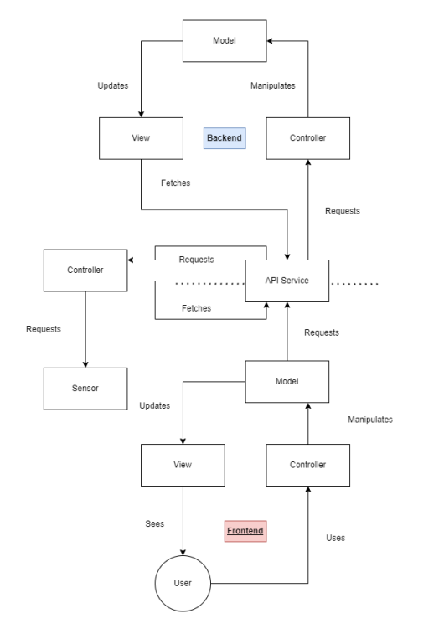

Figure 9 - IOT System Architecture

## INTRODUCTION TO DATABASE DESIGN

### ENTITY RELATIONSHIP DIAGRAM (ERD)

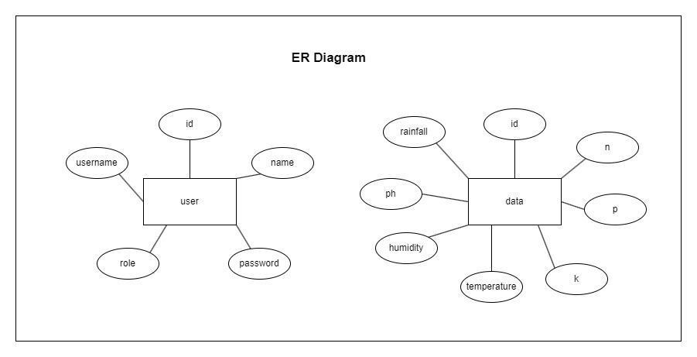

Figure 10 - ER Diagram

1. CHAPTER 8: IMPLEMENTATION

## IMPLEMENTATION OVERVIEW

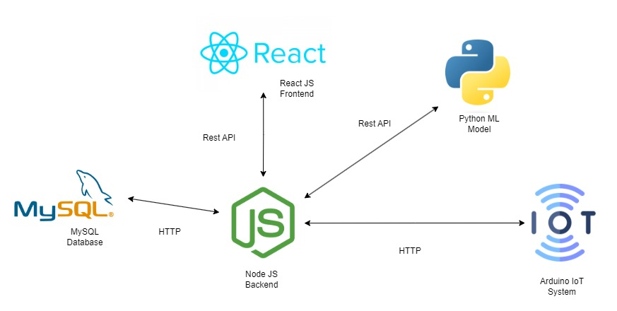

Figure 11 - Implementation Overview

Our project's implementation, which uses IoT and machine learning to optimize plant cultivation practices, is organized into a coherent, multi-phase approach that is intended to methodically handle the different parts and phases required for the project's successful completion. Establishing the project's foundation is the main goal of the first phase. This entails outlining the goals, parameters, and anticipated deliverables of the project in order to make sure that everyone involved is aware of its course and expected results. Establishing a version control system using Git to enable collaborative development and version tracking is a crucial component of this phase. The project infrastructure is also established, with project structure and directories put up to facilitate a productive workflow.

Following the project setup, attention shifts to data collection and preprocessing. This stage is critical, as the quality and comprehensiveness of the data directly influence the effectiveness of the machine learning models. Data pertaining to NPK levels, temperature, humidity, pH, and rainfall are gathered and undergo preprocessing to address missing values, outliers, and to engineer features that are conducive to predictive modeling.

The subsequent phase is dedicated to the development and training of machine learning models tailored to predict optimal plant growth conditions. This involves selecting appropriate models, setting up the Python environment, and experimenting with different architectures and parameters to refine the models' accuracy and reliability. In parallel, development efforts extend to the creation of a user-friendly web application, encompassing both frontend and backend development, and the integration of IoT devices for real-time data acquisition.

The final phase of implementation engages in a detailed analysis of the variables critical to plant growth and the generation of actionable insights. Through variable importance analysis, key factors influencing plant growth recommendations are identified, allowing for a deeper understanding of the environmental determinants of plant health. The project culminates in the interpretation of the findings and the dissemination of insights, providing valuable guidance on optimal plant choices based on comprehensive environmental data.

This systematic approach to implementation, marked by clearly defined phases and focused activities, ensures that the project progresses in a structured manner towards achieving its aim of leveraging technology to enhance plant cultivation practices.

## USER INTERFACES

### USER INPUT INTERFACE DESIGNS



Figure 12 - Add user interface

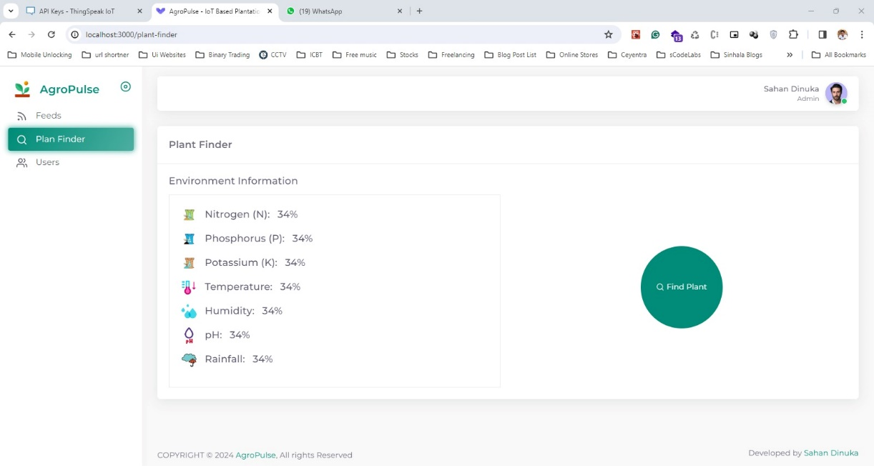

Figure 13 - Plant Finder Interface



Figure 14 - User Deletion Confirmation



Figure 15 - User Information Update Form

### USER OUTPUT INTERFACE DESIGNS

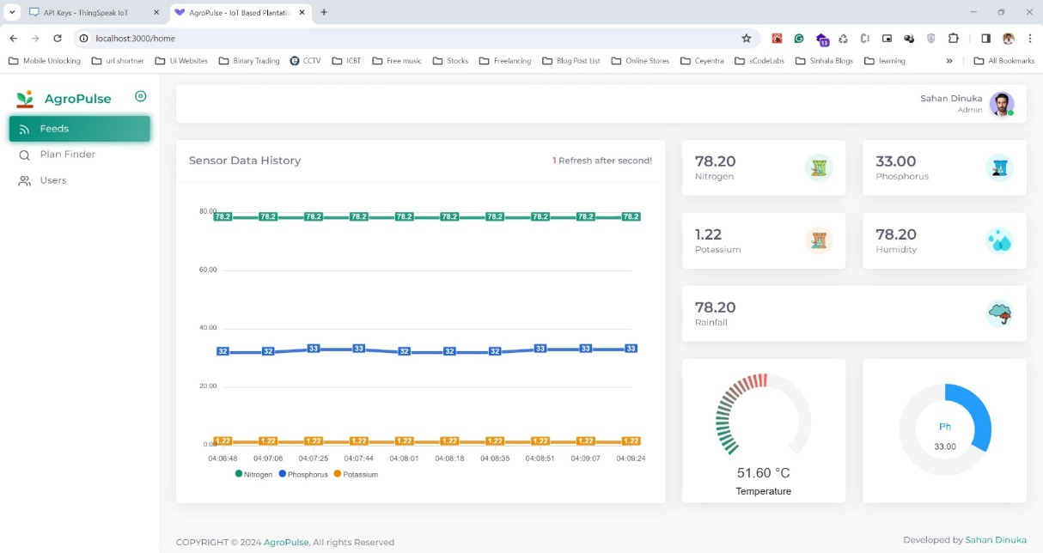

Figure 16 - Environmental Monitoring Dashboard

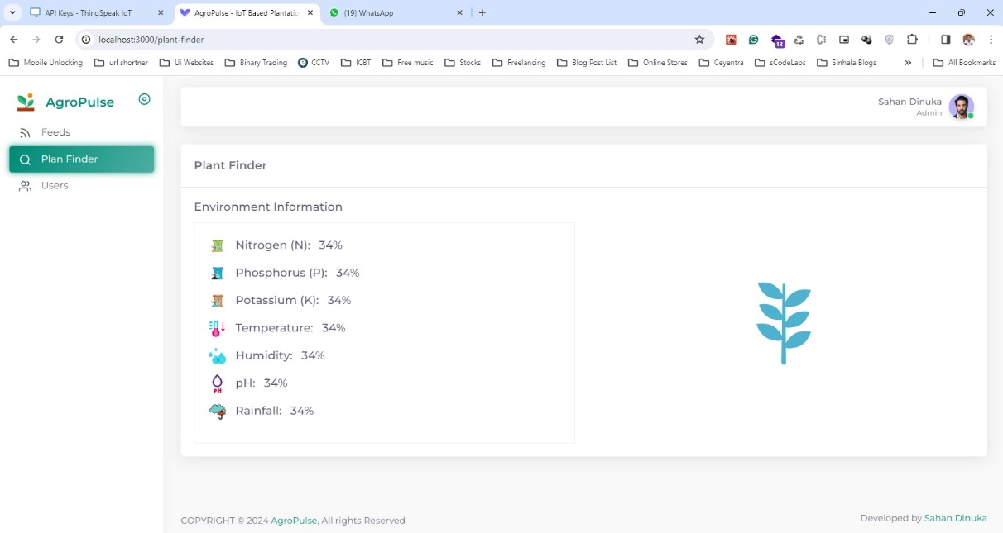

Figure 17 - Plant Selection Feature Interface



Figure 18 - User Management Panel



Figure 19 - Successfully found the ideal Plant UI

1. CHAPTER 9: TESTING

## TESTING OVERVIEW

Testing is an essential component of the software development lifecycle, especially for systems that make use of the Internet of Things and machine learning. It ensures the durability, accuracy, and utility of the final output. Due to the complexity of our project, a comprehensive testing strategy comprising functional, regression, integration, and unit testing has been created in order to evaluate every part of the system in detail.

## TEST STRATEGY -UNIT TESTING

Our testing methodology is based on unit testing, which verifies that even the smallest bits of code—individual functions and methods—run as intended. We employ unit tests in our project to formally validate the precision of data preparation processes, IoT data collection scripts, and machine learning model operations. Mock objects and data are used in order to mimic real-world conditions and ensure that each component works as intended when used alone. This approach simplifies the debugging process and helps find defects earlier.

### TEST STRATEGY -INTEGRATION TESTING

Integration testing evaluates how several system modules work together after unit testing validates each component separately. The testing step is critical to detecting any problems that may occur when various components of the system interact, including the integration of machine learning models with the web application frontend or the data flow between IoT sensors and the backend server. The purpose of integration tests is to guarantee that the system's components work together seamlessly to accomplish their intended tasks and that data integrity is preserved throughout.

### TEST STRATEGY- FUNCTIONAL TESTING

Functional testing compares the system's performance to its functional requirements to make sure end users may expect it to operate as intended. Testing the system's capacity to forecast ideal plant growth circumstances based on environmental data, the precision of machine learning forecasts, and the responsiveness and usability of the user interface are all included in this. To ensure that the system satisfies all needs and offers a satisfactory user experience, test cases are created based on user stories and specifications to cover every scenario in which a user may interact with the system.

### TEST STRATEGY – REGRATION TESTING

Regression testing is done to make sure that recent code modifications haven't negatively impacted the system's current functions. This becomes especially crucial in projects that include frequent codebase upgrades through continuous integration and deployment. Every major update is followed by automated regression testing, especially after incorporating new machine learning models or IoT sensor data, to quickly identify and fix any unexpected side effects. This strategy aids in preserving the stability and dependability of the system both during development and after deployment.

When combined, these testing techniques offer a strong foundation for guaranteeing the system's dependability and quality, enabling the effective deployment of an Internet of Things (IoT) and machine learning-based solution for improving plant cultivation techniques.

## TEST PLAN AND TEST CASES

**Objective**: Validate the functionality, performance, and reliability of the Plant Cultivation and Monitoring Solution, ensuring it meets all specified requirements and operates correctly in expected and stress conditions.

**Scope**:

* Functionality of the IoT integration for real-time monitoring.
* Machine learning model's accuracy and predictive performance.
* User interface usability and responsiveness.
* System's performance under normal and peak loads.
* Security and data integrity.

**Test Strategy**:

1. **Unit Testing**: Test individual components for correct behavior.
2. **Integration Testing**: Ensure that integrated components function together as expected.
3. **System Testing**: Validate the complete and integrated software product.
4. **Performance Testing**: Measure the system's performance parameters including response time and stability.
5. **Usability Testing**: Assess the ease of use and user interaction quality.
6. **Security Testing**: Verify encryption, data integrity, and protection against threats.

|  |  |
| --- | --- |
| **Field** | **Details** |
| **Test Case ID** | TC001 |
| **Description** | Validate the accurate real-time data collection from IoT sensors. |
| **Preconditions** | IoT sensors are installed and operational. |
| **Test Steps** | 1. Simulate input for temperature, humidity, and soil moisture sensors. 2. Observe data transmission to the dashboard. |
| **Expected Result** | Data from sensors is accurately captured and displayed on the dashboard in real-time. |

Table 1 - Test Case 1 - Real Time Data Collection

This test case focuses on ensuring that the IoT sensors integrated with the Plant Cultivation and Monitoring Solution can accurately capture and transmit data in real-time. The validation process involves simulating environmental conditions using sensors that measure temperature, humidity, and soil moisture. The expected outcome is that this data should be reflected immediately on the system’s dashboard, demonstrating the system’s capability to monitor conditions effectively without delays, which is crucial for timely decision-making in agricultural environments.

|  |  |
| --- | --- |
| **Field** | **Details** |
| **Test Case ID** | TC002 |
| **Description** | Verify the predictive accuracy of the machine learning model. |
| **Preconditions** | Historical data for model training is loaded into the system. |
| **Test Steps** | 1. Input new environmental data into the system.  2. Run the prediction model.  3. Record the output. |
| **Expected Result** | Predictions are within the predefined error margin; results are consistent and reliable. |

Table 2 - Test Case 2 - ML Model Predictive Accuracy

This test assesses the accuracy of the machine learning model used to predict agricultural outcomes based on environmental data. The model should have been previously trained with historical data to ensure its readiness for live predictions. This test involves providing new data as input to see how the model predicts outcomes like crop health or growth conditions. The crucial aspect here is that the predictions should fall within an acceptable error range predefined by the system’s specifications, highlighting the model's reliability and effectiveness in practical applications.

|  |  |
| --- | --- |
| **Field** | **Details** |
| **Test Case ID** | TC003 |
| **Description** | Assess the usability of the user interface. |
| **Preconditions** | User interface is accessible via a web browser. |
| **Test Steps** | 1. Navigate through all UI elements (buttons, links, forms).  2. Enter data into forms.  3. Retrieve data from the system. |
| **Expected Result** | All UI elements are functional, and navigation is intuitive without unresponsive periods. |

Table 3 - Test Case 3 - User Interface Usability

This test evaluates the user interface (UI) of the system to ensure that it is user-friendly and efficient. The test involves navigating through all the UI components, entering data into forms, and retrieving data to verify that all elements operate seamlessly and intuitively. The goal is to confirm that users can interact with the system effectively, without encountering issues like crashes or slow responses, which could impede usability.

|  |  |
| --- | --- |
| **Field** | **Details** |
| **Test Case ID** | TC004 |
| **Description** | Evaluate system performance under peak load conditions. |
| **Preconditions** | System is operational at standard user and data load. |
| **Test Steps** | 1. Simulate multiple users logging in and inputting data simultaneously.  2. Monitor system response and speed. |
| **Expected Result** | System handles peak loads with no significant degradation in performance or response times. |

Table 4 - Test Case 4 - System Performance Under Peak Load

This test case aims to assess the robustness of the system when subjected to peak load conditions, simulating a high number of simultaneous users and data entries. The purpose is to ensure that the system can handle high traffic and data throughput without a decrease in performance or responsiveness. This is crucial for real-world scenarios where the system must remain reliable during critical times of heavy usage.

|  |  |
| --- | --- |
| **Field** | **Details** |
| **Test Case ID** | TC005 |
| **Description** | Confirm data encryption and security during transmission. |
| **Preconditions** | Data transmission paths are active. |
| **Test Steps** | 1. Intercept data transmission between sensors and server.  2. Attempt to decrypt the data using standard decryption tools. |
| **Expected Result** | Data is encrypted during transmission and unreadable without correct decryption keys. |

Table 5 - Test Case 5 - Data Encryption and Security

This test verifies the security measures in place to protect data transmitted between IoT sensors and the server. It involves intercepting the data to check whether it is encrypted properly, ensuring that it cannot be deciphered by unauthorized parties. This test is critical for maintaining data integrity and confidentiality, protecting sensitive agricultural data from potential security breaches.

**Test Environment**:

* Hardware: IoT sensors, servers, and user devices.
* Software: Operating systems, network configurations, database systems.
* Tools: Test management tools, performance testing tools, security testing tools.

**Responsibilities**:

* Test management and execution will be handled by the QA team.
* Developers will address bugs and implement fixes.
* Stakeholders will provide necessary resources and ensure environment availability.

**Schedule**: Detailed timelines for planning, execution, and evaluation phases, synchronized with the development lifecycle.

**Deliverables**:

* Test cases and scripts.
* Test reports including bug reports and performance analysis.
* Final test summary report.

|  |  |  |  |  |
| --- | --- | --- | --- | --- |
| **Test Case ID** | **Description** | **Preconditions** | **Test Steps** | **Expected Results** |
| TC006 | Login with Partially Entered Credentials | System is operational and user credentials are known. | 1. Enter only username or password.  2. Attempt to log in. | The system should not allow login and display an error message requesting complete credentials. |
| TC007 | Login with Various User Roles | Different user roles exist in the system. | 1. Log in with credentials specific to different roles.  2. Access role-specific functionalities. | Each user role should be able to log in and access functions permissible under their role only. |
| TC008 | Case-Sensitivity Check in Username and Password | User credentials are case-sensitive. | 1. Enter username and password with different case variations.  2. Attempt to log in. | Login should only be successful if the credentials match the exact case as stored. |
| TC009 | Session Timeout Verification | User is logged in. | 1. Log in and remain inactive for the specified timeout period  2. Attempt to use the system post-timeout. | The system should automatically log out the user after the period of inactivity. |

Table 6 - Test Cases for the Login Function

|  |  |  |  |  |
| --- | --- | --- | --- | --- |
| **Test Case ID** | **Description** | **Preconditions** | **Test Steps** | **Expected Results** |
| TC010 | Predict with Imbalanced Nutrient Values | Prediction system is set up to handle various nutrient inputs. | 1. Input imbalanced nutrient levels into the system.  2. Obtain and review the prediction. | The system should provide accurate predictions despite nutrient imbalances, or highlight inaccuracies if present. |
| TC011 | Predict with Extreme Weather Conditions | Data for extreme weather conditions is available. | 1. Input extreme weather data into the prediction model.  2. Obtain and review the prediction. | The model should handle extreme data robustly and provide realistic outputs. |
| TC012 | Prediction Feedback Loop | System has a feedback mechanism for improving predictions. | 1. Provide feedback on initial predictions. 2. Repeat prediction with similar data. | The system should learn from feedback and improve the accuracy of subsequent predictions. |
| TC013 | Comprehensive Predictive Analysis | All relevant environmental factors can be integrated into the prediction model. | 1. Enter a comprehensive set of environmental data.  2. Obtain and review the prediction. | The model should utilize the multifaceted data to generate an encompassing prediction. |

Table 7- Test cases for the Prediction

|  |  |  |  |  |
| --- | --- | --- | --- | --- |
| **Test Case ID** | **Description** | **Preconditions** | **Test Steps** | **Expected Results** |
| TC014 | User Role Change Impact | User roles are definable and modifiable. | 1. Change a user's role. 2. Verify changes in access permissions. | The system should update access as per the new role immediately after the change. |
| TC015 | User Update with Special Characters | Special characters are allowable in user details. | 1. Update user details to include special characters.  2. Save changes and retrieve the updated details. | Special characters should be stored correctly and displayed accurately in the user details. |
| TC016 | Bulk User Operations | System supports bulk data handling. | 1. Perform bulk add/delete operations.  2. Verify the changes in the system. | The system should handle bulk operations efficiently without errors or performance degradation. |
| TC017 | User Data Validation | User creation and update forms are active. | 1. Enter incomplete or incorrect format data.  2. Attempt to save the user details. | The system should enforce data completeness and correct format, displaying errors if the input is invalid. |

Table 8 - Test cases for the CRUD operations

# CHAPTER 10: MAINTENANCE

## OVERVIEW OF MAINTENANCE

Any software application's lifespan must include maintenance, but it's especially important for sophisticated systems that combine web technologies, machine learning models, and Internet of Things sensors. Ongoing maintenance guarantees that the IoT and machine learning-based technology meant to improve plant cultivation techniques is effective, usable, and relevant to user demands. This application's maintenance plan includes corrective, adaptive, perfective, and preventative maintenance, among other important topics.

1. Corrective Maintenance

Corrective maintenance involves identifying and fixing bugs or defects in the system after deployment. For our application, this includes resolving issues that emerge in the integration of IoT sensors with the data collection platforms, inaccuracies in machine learning predictions, or failures in data processing pipelines. A robust bug tracking and resolution system will be essential, utilizing user feedback and automated error logging to quickly address and rectify problems. Continuous monitoring tools will be employed to detect system anomalies and performance dips in real time, ensuring immediate corrective actions can be taken.

1. Adaptive Maintenance

As technology and user requirements evolve, adaptive maintenance ensures the application remains compatible with new software versions, hardware updates, and changes in external APIs. This may involve updating machine learning libraries, upgrading IoT firmware, or modifying the system to comply with new data privacy laws affecting data collection and processing. Regular reviews of technological advancements and regulatory changes will be scheduled to ensure the system adapts effectively to external changes.

1. Perfective Maintenance

Perfective maintenance will be regularly carried out based on user input and new scientific insights into plant culture in order to improve the application's functionality and performance. This entails improving the usability of already-existing features, introducing new ones, and enhancing machine learning algorithms to increase forecast accuracy. It will be developed to regularly collect input from end users, such as farmers and agricultural specialists, in order to identify possible areas for improvement.

1. Preventive Maintenance

The goal of preventive maintenance is to anticipate and stop issues before they arise. This entails doing routine audits of the software and system architecture, updating documentation, and putting better security and data handling procedures into place. In order to ensure that users can utilize the system efficiently and reduce operational risks, preventive measures also include training sessions for users on new features and best practices.

Schedule of Maintenance and Related Documentation:

A detailed maintenance schedule will be developed, specifying the timing of routine checks, updates, and audits. This schedule will be aligned with the agricultural seasons to minimize disruption to the users. Comprehensive documentation will be maintained, detailing every aspect of the system's operation, maintenance procedures, and user guidelines. This documentation will be regularly updated to reflect any changes made during maintenance cycles.

By adhering to this comprehensive maintenance strategy, the application will not only sustain its operational capabilities but also continuously evolve in alignment with technological advancements and user expectations, thereby maximizing its longevity and effectiveness in improving plant cultivation practices.

1. CHAPTER 11: CRITICAL EVALUATION AND CONCLUSION

## SUMMARY OF THE PROJECT

In order to improve plant cultivation techniques, this research has created an integrated system that combines the power of machine learning with the Internet of Things. The system makes accurate suggestions for ideal plant development circumstances by utilizing real-time environmental data and predictive analytics. It takes into account several crucial elements, including rainfall, temperature, humidity, pH, and NPK levels. The project was divided into three key stages: setup and data gathering, model creation and training, and analysis and insights production. Each stage was thoughtfully planned to build on the one before it, guaranteeing a finished output that is both coherent and useful.

Phase 1: Setup and Data Collection started the project by establishing the necessary infrastructure, such as version control and project directories, and clearly specifying the goals and deliverables. High-quality data collection was a major focus of this phase, as it is essential to the precision of machine learning models. This entailed placing Internet of Things (IoT) sensors throughout various Sri Lankan agricultural locations in order to collect real-time data that was subsequently carefully preprocessed to guarantee accuracy.

Phase 2: Model Development and Training comprised choosing suitable machine learning models according to the project objectives and the properties of the data. Regression, Decision Tree, and Random Forest models were constructed and trained using Python and tools like scikit-learn and TensorFlow. In order to attain high accuracy and dependability in forecasting plant growth conditions, this phase concentrated on fine-tuning and optimizing the models.

Phase 3: The technological efforts culminated in Analysis and Insights Generation, when the trained models were deployed to provide useful insights. A thorough analysis of the significance of several environmental conditions resulted in well-informed advice for farmers. In order to make it easier to acquire these insights, a user-friendly online interface that integrates IoT data streams for real-time monitoring and decision-making was also built.

Feasibility studies were emphasized heavily throughout the project to guarantee the solution's viability and durability. The project's feasibility in actual agricultural contexts was confirmed by a detailed evaluation of its technical, financial, economic, and environmental viability.

In order to minimize interruptions and maximize relevance, the implementation required meticulous planning and execution in accordance with a defined calendar that coincided with agricultural cycles. To make sure the system was reliable and resilient, testing techniques included functional, regression, integration, and unit testing.

Let's sum up by saying that this study has effectively shown how IoT and machine learning may transform plant growing methods and advance sustainable agriculture. It has tackled significant issues with model accuracy, data collecting and analysis, and user accessibility, offering a scalable system that can adjust to various agricultural conditions and demands. The tactics delineated for continual development and continuing maintenance guarantee that the system will be effective and relevant, molding itself to future technology breakthroughs and changing user needs.

## EVALUATION OF THE SOLUTION

The evaluation of the machine learning models implemented in this project is crucial for validating the effectiveness of the integrated IoT and machine learning solution designed to optimize plant cultivation. The models selected—regression, decision tree, and random forest—were rigorously tested to measure their accuracy and reliability in predicting optimal plant growth conditions based on environmental factors such as NPK levels, temperature, humidity, pH, and rainfall.

Regression Model: A perfect match to the training set of data was shown by the regression model's accuracy of 1.0. The main reason this model was used was because of its capacity to forecast continuous results, including the extent to which each environmental element affects plant development. The model appears to have been extraordinarily well-tuned to the dataset, capturing all underlying patterns without any errors, based on the 100% accuracy score. A high score, meanwhile, also begs the question of overfitting—the possibility that the model is too tightly suited to the training set, which might have an impact on how well it performs on untested data.

Decision Tree Model: The decision tree model showed good dependability, but marginally less than the regression model, with an accuracy of 0.9. Decision trees are renowned for being simple to understand and for being able to represent non-linear connections. The accuracy attained suggests that, in contrast to the regression model, the decision tree model was successful in capturing the majority of the variability in the data without being as prone to overfitting. Because of its ability to balance generalizability and accuracy, decision trees are a reliable option for situations in which the data may differ significantly from the training set.

Random Forest Model: Like the regression model, the random forest achieved a perfect accuracy score of 1.0. As an ensemble method that combines multiple decision trees to improve predictive performance and control overfitting, the random forest's perfect score reflects its capability to effectively generalize across the data while mitigating issues like overfitting seen in single decision trees. The high accuracy underscores the model’s robustness, making it highly reliable for practical applications in predicting plant growth conditions.

Overall Evaluation: The high accuracies reported by all models indicate a strong predictive performance, crucial for the application's success in providing accurate recommendations for plant cultivation. The difference in model performances also illustrates the importance of selecting a diverse set of algorithms to address various aspects of the data. It is essential, however, to consider these results within the context of the project's scope and the quality of data collected. While perfect or near-perfect accuracies are desirable, they necessitate further validation to ensure models are not overfitting but are truly predictive of real-world scenarios.

The capacity of these models to correctly forecast ideal plant conditions may greatly assist farmers in their decision-making, improving the effectiveness and sustainability of agricultural methods. Maintaining the accuracy and usefulness of these models in the face of changing climatic conditions and agricultural practices would require constant monitoring and updating with fresh data. This assessment not only validates the solution's feasibility but also identifies areas that need to be continuously enhanced and improved upon in subsequent project iterations.

## LIMITATIONS OF THE SYSTEM

Notwithstanding the noteworthy accomplishments and progress exhibited by the Agriculture Plant Prediction Project, it is critical to acknowledge the intrinsic constraints and possible obstacles that may impact the dependability and relevance of the results. These restrictions are essential for comprehending the breadth of the project's findings as well as for directing future advancements and lines of inquiry.

Data Availability and Quality: The models' ability to forecast outcomes is significantly dependent on the availability, correctness, and quality of the information gathered, which includes NPK levels, rainfall, temperature, humidity, and pH. Restrictions on the quantity or quality of data available for these factors may result in inaccurate forecasts, which may impact the process of making decisions based on these models.

Environmental unpredictability: The complexity and unpredictability of agricultural ecosystems are well-known. Due to the inherent difficulties in accurately portraying a variety of environmental variables, the models may not account for all relevant elements. Furthermore, abrupt changes in the microclimate might cause the models to lose their relevance and produce suggestions that are less trustworthy.

Model Sensitivity: Significant differences in the output of predictive models can result from their sensitivity to hyperparameters, architectural decisions, and the details of the training data. This sensitivity highlights the need for rigorous model validation and adjustment in order to guarantee the resilience and dependability of the models.

External variables: Unpredictable external variables can affect the environment and, consequently, the growth of plants. Examples of these elements include odd weather, changes in the composition of the soil, and insect infestations. These elements are frequently hard to foresee and account for in models, which might restrict the model's flexibility in responding to novel or unexpected circumstances.

Restricted Prediction Scope: The variables and relationships specified in the models represent the whole range of predictions. The advice' broader application may be limited by factors that affect plant development but are not taken into consideration in the model because of limitations in the data set or model design.

Data Lag: Real-time data processing and analysis may experience delays due to IoT sensor data updates. The system's capacity to produce timely forecasts, which is essential for quick response measures in agricultural management, may be hampered by this delay.

Future Environmental Dynamics: Modifications in farming methods or changes in environmental circumstances brought on by climate change may jeopardise the prediction models' long-term validity. Because these parameters are dynamic, models may need to be continually adjusted and retrained in order to retain their accuracy and utility.

It is essential for the project's continued development and improvement to acknowledge these constraints. Improving data management procedures, using sophisticated modelling strategies, and updating the model often are necessary to overcome these obstacles and increase the project's efficacy and agriculture sector applicability.

## FUTURE ENHANCEMENTS

The Agriculture Plant Prediction Project has laid a solid foundation for the use of IoT and machine learning in agriculture. However, the project may undergo a lot of changes in the future to accommodate new technological advancements and evolving agricultural demands. These modifications aim to ensure the project's long-term existence and relevance by fixing current flaws and strengthening its capabilities.

Improved Quantity and Quality of Data: Increasing the amount and caliber of data collected by more sophisticated Internet of Things sensors might significantly raise the model's accuracy. Future efforts may focus on deploying advanced sensors that provide a greater variety of precise and diverse environmental evaluations. Moreover, more stringent data cleaning and validation procedures would guarantee better data quality for model training.

Expansion of Data Sources: Adding new data sources, such drone and satellite imaging, can give a more complete picture of the environment and the health of the plants. The integration of data from several sources would enable the development of more intricate and precise prediction models that evaluate a wider variety of plant growth parameters.

Model Complexity and Diversity: By investigating more intricate model designs and algorithms, the project's forecast accuracy and resilience may be improved. Better results may be obtained by experimenting with deep learning architectures or using ensemble models that incorporate several machine learning approaches, particularly when it comes to capturing nonlinear correlations and interactions among variables.

Real-Time Data Processing: In order to solve the problem of data lag, real-time data processing and analysis skills may be the focus of future improvements. By putting edge computing solutions in place, where data processing takes place on or close to IoT devices, reaction times may be significantly lowered, and predictive insights can be obtained more quickly.

Adaptation to External Changes: It's critical to create models that can adjust to shifting agricultural methods and environmental circumstances. Despite outside changes, adaptive learning systems can continue to be accurate and relevant over time by updating their parameters on a regular basis in response to fresh input.

User Interface and Decision Support Systems: Farmers and agricultural specialists might find the system more accessible and helpful if it has an improved user interface and incorporates extensive decision support features. Based on the model's predictions, these tools can assist users make decisions by offering practical insights and suggestions.

Extension to New Agricultural Domains: Future improvements might expand the project's reach to encompass more crop varieties and diverse agricultural settings, even if it now concentrates on a limited number of plant species and environs. This would increase the system's adaptability and enable it to be used in a greater variety of agricultural settings.

Sustainability and Environmental Impact: To make sure that the agricultural methods suggested by the models are in line with the objectives of environmental conservation, further iterations of the project may additionally include sustainability evaluations. This can entail incorporating evaluations of the whole ecological effect of advised farming techniques, as well as water use and carbon footprint.

The project may greatly increase its usability, accuracy, and relevance by pursuing these future improvements, adding more value to the agriculture industry and advancing sustainable farming methods in the process.

## LESSONS LERANED REPORT

Throughout the course of its development and deployment, the Agriculture Plant Prediction Project yielded a wealth of insightful knowledge and lessons that may direct future efforts in IoT and machine learning applications in the agricultural sector and beyond. The following are the main takeaways from the project:

1. Importance of Integrity and Data Quality: One of the most important lessons discovered is the substantial influence that data quality has on model performance. It became clear that the creation of trustworthy prediction models requires precise, hygienic, and complete data. The experiment demonstrated how outliers, missing values, and erroneous data points may significantly distort model results, necessitating thorough data validation and preparation.

2. Challenges of Real-Time Data Collection: The research brought to light the technological and logistical difficulties that come with using IoT devices to gather data in real-time. There were problems with transmission delays, data synchronization, and sensor calibration. It was discovered that consistent hardware maintenance and thorough testing are necessary to guarantee dependable and continuous data flow.

3. Complexity of Environmental factors: One major challenge was addressing the diversity and complexity of environmental factors. The experiment revealed that agricultural ecosystems are very dynamic and that models need to be flexible and adaptive to take sudden changes in the environment into account. This insight highlights how important it is to design models whose parameters may be modified in reaction to new data.

4. The project's multidisciplinary approach, which brought together machine learning, agriculture, and the Internet of Things, brought attention to the necessity of cross-disciplinary expertise. The project's successful completion was primarily made possible by the combined knowledge of experts from other sectors, proving how important it is to have a variety of skill sets when taking on challenging tasks.

5. User-Centric Design and Implementation: It has been found that for technological solutions to be fully adopted and exploited, end users must be at the core of the design process. Farmers and agricultural experts provided valuable feedback during the project's development, which enhanced the tools' usability and accessibility for the intended user base.

6. Flexibility and Scalability Concerns: It became evident as the research progressed that flexibility and scalability are essential for the broad adoption of technological solutions in agriculture. Designing systems that are easily scalable to numerous crop varieties and adaptive to varied farming techniques and settings was one of the lessons learnt.

7. Effect of External Factors: The research shed light on the ways in which outside variables, such unforeseen weather conditions or insect outbreaks, might affect forecasting models. The importance of strong models—perhaps with predictive elements that can foresee or respond to these outside influences—was underlined in this session.

8. Regulatory and Ethical Considerations: In conclusion, significant insights were gained on negotiating the regulatory landscape and keeping ethical issues in mind when gathering and utilizing data. The experiment demonstrated how crucial it is to continuously consider data security, privacy, and regulatory compliance when implementing IoT and data-driven solutions in sensitive industries like agricultural.

These lessons gained not only highlight the difficulties encountered, but they also show how future initiatives might build on the groundwork this one created. They operate as a thorough manual for negotiating the challenges of incorporating cutting-edge technologies into useful, everyday uses.

## CONCLUSION

An important development in the use of IoT and machine learning technology to agriculture is the Agriculture Plant Prediction Project. This initiative was created to meet a pressing demand by providing precise, data-driven insights to improve decision-making processes about plant development conditions. The project's conclusion offers a forward-looking viewpoint on the possibilities of technology in agriculture in addition to reflecting the successes and challenges faced.

Project accomplishments: Regression, decision trees, random forests, and other sophisticated machine learning models are combined with real-time data collecting via Internet of Things (IoT) devices in a reliable system that has been designed and put into operation. The efficacy of these models in forecasting ideal plant development circumstances based on environmental factors including temperature, humidity, pH, NPK levels, and rainfall is demonstrated by their high accuracy levels. Farmers now have actionable insights thanks to the actual use of these models in an intuitive web tool, which has improved agricultural practices and increased crop yields.

Technological Innovations: This project's skillful integration of several different technologies is one of its most notable accomplishments. The use of machine learning algorithms on Python platforms and the real-time data collecting using Arduino boards constituted a major technological synergy that propelled the project's success. Furthermore, the project's dedication to developing a scalable and accessible platform was demonstrated by the construction of a frontend web application using ReactJS and backend services using NodeJS.

Challenges and Learnings: The project faced a number of difficulties over its many phases, including problems with data quality, erratic environmental conditions, and integrating complicated systems. Every task imparted significant knowledge, especially about data management, model sensitivity, and the significance of a user-centered design methodology. Another crucial area of learning was the requirement to foresee and reduce the influence of external environmental influences on predicted accuracy.

Future Directions: The project has established a strong basis for further improvements. Potential developments might involve using a wider range of data sources, including data from deeper soil analyses or satellite photography, to further improve the models. Additionally, the model's applicability may be extended to various crop kinds and geographical areas in order to accommodate changing agricultural demands and practices worldwide. The system's usefulness might also be greatly increased by including predictive analytics for the prediction of pests and diseases and enhancing the models to account for abrupt changes in the environment.

Impact on Agriculture and Beyond: This project's ramifications go beyond the field of agriculture. This project provides as an example for other industries hoping to employ technology to improve data utilization and decision-making by showcasing the efficient application of IoT and machine learning. It serves as evidence of the effectiveness of multidisciplinary teamwork and technical innovation in resolving pressing issues.

In conclusion, the Agriculture Plant Prediction Project not only achieved its goal of enhancing agricultural decision-making through technological innovation but also illuminated the path forward for future research and development in this vital sector. As we look to the future, the continued evolution of this project and its methodologies will undoubtedly play a pivotal role in the transformation of agricultural practices worldwide.

# REFERENCES

AbdelRahman, M. A. E., Saleh, A. M., & Arafat, S. M. (2022). Assessment of land suitability using a soil-indicator-based approach in a geomatics environment. *Scientific Reports*, *12*(1). <https://doi.org/10.1038/s41598-022-22727-7>

Abubakar, A., Ishak, M. Y., Uddin, M. K., Abu Bakar, A., & Mohammed, M. U. (2023). What does Modelling Tells us on the Influence of Certain Weather Parameters on Oil Palm Production in Peninsular Malaysia. *Indian Journal of Agricultural Research*, *57*(1). <https://doi.org/10.18805/IJARe.AF-715>

Affoh, R., Zheng, H., Zhang, X., Yu, W., & Qu, C. (2023). Influences of Meteorological Factors on Maize and Sorghum Yield in Togo, West Africa. *Land*, *12*(1). <https://doi.org/10.3390/land12010123>

Ahmed, U., Lin, J. C. W., Srivastava, G., & Djenouri, Y. (2021). A nutrient recommendation system for soil fertilization based on evolutionary computation. *Computers and Electronics in Agriculture*, *189*. <https://doi.org/10.1016/j.compag.2021.106407>

Alhajj Ali, S., Vivaldi, G. A., Garofalo, S. Pietro, Costanza, L., & Camposeo, S. (2023). Land Suitability Analysis of Six Fruit Tree Species Immune/Resistant to Xylella fastidiosa as Alternative Crops in Infected Olive-Growing Areas. *Agronomy*, *13*(2). <https://doi.org/10.3390/agronomy13020547>

Ali, S., Liu, Y., Ishaq, M., Shah, T., Abdullah, Ilyas, A., & Din, I. U. (2017). Climate change and its impact on the yield of major food crops: Evidence from pakistan. *Foods*, *6*(6). <https://doi.org/10.3390/foods6060039>

Appelt, J. L., Saphangthong, T., Malek, Ž., Verburg, P. H., & van Vliet, J. (2023). Climate change impacts on tree crop suitability in Southeast Asia. *Regional Environmental Change*, *23*(3). <https://doi.org/10.1007/s10113-023-02111-5>

Baldini, M., Ferfuia, C., Zuliani, F., & Danuso, F. (2020). Suitability assessment of different hemp (Cannabis sativa L.) varieties to the cultivation environment. *Industrial Crops and Products*, *143*. <https://doi.org/10.1016/j.indcrop.2019.111860>

Chiu, M. C., Chen, C. L., Chen, C. W., & Lin, H. J. (2022). Weather fluctuation can override the effects of integrated nutrient management on fungal disease incidence in the rice fields in Taiwan. *Scientific Reports*, *12*(1). <https://doi.org/10.1038/s41598-022-08139-7>

Confalonieri, R., Francone, C., Cappelli, G., Stella, T., Frasso, N., Carpani, M., Bregaglio, S., Acutis, M., Tubiello, F. N., & Fernandes, E. (2013). A multi-approach software library for estimating crop suitability to environment. *Computers and Electronics in Agriculture*, *90*. <https://doi.org/10.1016/j.compag.2012.09.016>

Dharmarathna, W. R. S. S., Weerakoon, S. B., Rathnayake, U. R., & Herath, S. (2011). Testing Suitability of DSSAT Model for Rice Varieties Grown in Kurunegala District, Sri Lanka. *5th UN-CECAR Conference on Disaster Risk Management & Sustainability*.

Dwamena, H. A., Tawiah, K., & Akuoko Kodua, A. S. (2022). The Effect of Rainfall, Temperature, and Relative Humidity on the Yield of Cassava, Yam, and Maize in the Ashanti Region of Ghana. *International Journal of Agronomy*, *2022*. <https://doi.org/10.1155/2022/9077383>

Egbebiyi, T. S., Crespo, O., Lennard, C., Zaroug, M., Nikulin, G., Harris, I., Price, J., Forstenhäusler, N., & Warren, R. (2020). Investigating the potential impact of 1.5, 2 and 3 ◦C global warming levels on crop suitability and planting season over West Africa. *PeerJ*, *2020*(3). <https://doi.org/10.7717/peerj.8851>

Egbebiyi, T. S., Lennard, C., Crespo, O., Mukwenha, P., Lawal, S., & Quagraine, K. (2019). Assessing future spatio-temporal changes in crop suitability and planting season over West Africa: Using the concept of crop-climate departure. *Climate*, *7*(9). <https://doi.org/10.3390/cli7090102>  
  
  
  
  
Gardner, A. S., Maclean, I. M. D., Gaston, K. J., & Bütikofer, L. (2021). Forecasting future crop suitability with microclimate data. *Agricultural Systems*, *190*. <https://doi.org/10.1016/j.agsy.2021.103084>

Haque, M. N., Fatema, K., & Joy, M. A. R. (2022). Crop suitability analysis by adopting geo-spatial algorithm: a case study of Sirajganj district (flood-prone area) in Bangladesh. *Arab Gulf Journal of Scientific Research*, *40*(4). <https://doi.org/10.1108/AGJSR-07-2022-0118>

He, L. L., Huang, D. Y., Zhang, Q., Zhu, H. H., Xu, C., Li, B., & Zhu, Q. H. (2021). Meta-analysis of the effects of liming on soil pH and cadmium accumulation in crops. In *Ecotoxicology and Environmental Safety* (Vol. 223). <https://doi.org/10.1016/j.ecoenv.2021.112621>

He, L., Wang, S., Peng, C., & Tan, Q. (2018). Optimization of water consumption distribution based on crop suitability in the middle reaches of Heihe River. *Sustainability (Switzerland)*, *10*(7). <https://doi.org/10.3390/su10072119>

Holland, J. E., White, P. J., Glendining, M. J., Goulding, K. W. T., & McGrath, S. P. (2019). Yield responses of arable crops to liming – An evaluation of relationships between yields and soil pH from a long-term liming experiment. *European Journal of Agronomy*, *105*. <https://doi.org/10.1016/j.eja.2019.02.016>

Jayathilaka, P. M. S., Soni, P., Perret, S. R., Jayasuriya, H. P. W., & Salokhe, V. M. (2012). Spatial assessment of climate change effects on crop suitability for major plantation crops in Sri Lanka. *Regional Environmental Change*, *12*(1). <https://doi.org/10.1007/s10113-011-0235-8>

Khouloud Abida, Mariem Barbouchi, Khaoula Boudabbous, Haithem Bahri, Habib Bousnina, & Thouraya Sahli Chahed. (2023). Land suitability assessment of soils using geographic information system in the semi-arid area of Tunisia. *GSC Advanced Research and Reviews*, *15*(2). <https://doi.org/10.30574/gscarr.2023.15.2.0145>

Malaviarachchi, M. A. P. W. K., Costa, W. A. J. M. De, Fonseka, R. M., Kumara, J. B. D. A. P., Abhayapala, K. M. R. D., & Suriyagoda, L. D. B. (2015). Response of Maize (Zea mays L.) to a Temperature Gradient Representing Long-Term Climate Change Under Different Soil Management Systems. *Tropical Agricultural Research*, *25*(3). <https://doi.org/10.4038/tar.v25i3.8043>

Manners, R., Vandamme, E., Adewopo, J., Thornton, P., Friedmann, M., Carpentier, S., Ezui, K. S., & Thiele, G. (2021). Suitability of root, tuber, and banana crops in Central Africa can be favoured under future climates. *Agricultural Systems*, *193*. <https://doi.org/10.1016/j.agsy.2021.103246>

Manners, R., Varela-Ortega, C., & van Etten, J. (2020). Protein-rich legume and pseudo-cereal crop suitability under present and future European climates. *European Journal of Agronomy*, *113*. <https://doi.org/10.1016/j.eja.2019.125974>

Nti, I. K., Zaman, A., Nyarko-Boateng, O., Adekoya, A. F., & Keyeremeh, F. (2023). A predictive analytics model for crop suitability and productivity with tree-based ensemble learning. *Decision Analytics Journal*, *8*. <https://doi.org/10.1016/j.dajour.2023.100311>

Ogunkanmi, L., Maccarthy, D. S., & Adiku, S. G. K. (2022). Impact of Extreme Temperature and Soil Water Stress on the Growth and Yield of Soybean (Glycine max (L.) Merrill). *Agriculture (Switzerland)*, *12*(1). <https://doi.org/10.3390/agriculture12010043>

Shaloo, Singh, R. P., Bisht, H., Jain, R., Suna, T., Bana, R. S., Godara, S., Shivay, Y. S., Singh, N., Bedi, J., Begam, S., Tamta, M., & Gautam, S. (2022). Crop-Suitability Analysis Using the Analytic Hierarchy Process and Geospatial Techniques for Cereal Production in North India. *Sustainability (Switzerland)*, *14*(9). <https://doi.org/10.3390/su14095246>

Soberano, K. T., Pisueña, J. S., Tee, S. M. R., Arroyo, J. C. T., & Delima, A. J. P. (2023). Predictive soil-crop suitability pattern extraction using machine learning algorithms. *International Journal of Advanced and Applied Sciences*, *10*(6). <https://doi.org/10.21833/ijaas.2023.06.002>

von Tucher, S., Hörndl, D., & Schmidhalter, U. (2018). Interaction of soil pH and phosphorus efficacy: Long-term effects of P fertilizer and lime applications on wheat, barley, and sugar beet. *Ambio*, *47*. <https://doi.org/10.1007/s13280-017-0970-2>

Wang, Y. C., Lu, Y. H., Chiang, L. C., & Hsu, C. C. (2023). Assessing Crop Suitability of Rice, Wheat, and Maize on Agricultural Lands in Taiwan. *Natural Resources Research*, *32*(2). https://doi.org/10.1007/s11053-023-10162-y

APPENDIX A: TEST CASES WITH RESULTS

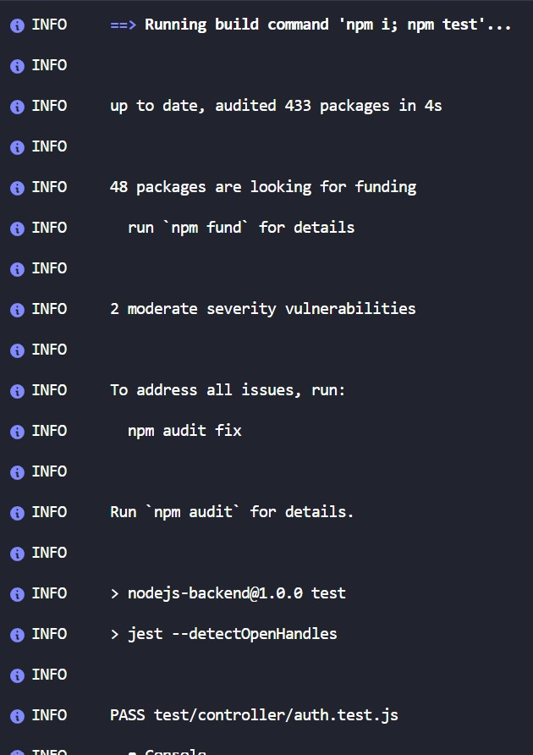

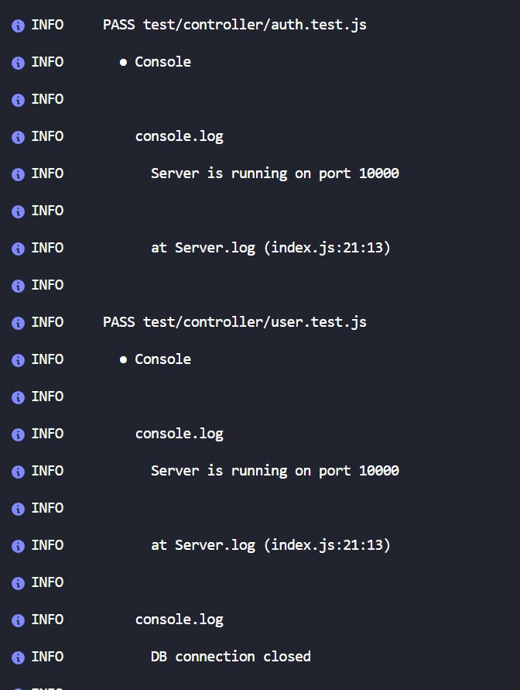

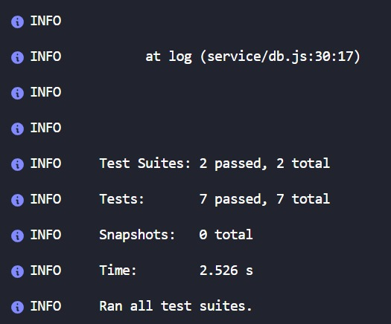

APPENDIX B: USER MANUAL

APPENDIX C: PROJECT LOG SHEETS